Modeling the impact of whole blood pathogen inactivation on risk of transfusion-related adverse events and healthcare spending in Ghana

W. Alton Russell1,2, Shirley Owusu-Ofori3, Alex Owusu-Ofori4,5, Eileen Micah6, Betty Norman3,4, Brian Custer2,7

1Department of Management Science and Engineering, Stanford University Stanford, CA

2Vitalant Research Institute, San Francisco, CA

3Transfusion Medicine Unit, Komfo-Anokye Teaching Hospital, Kumasi, Ghana

4Laboratory Services Directorate, Komfo-Anokye Teaching Hospital, Kumasi, Ghana

5Department of Clinical Microbiology, Nkrumah University of Science and Technology, Kumasi, Ghana

6Department of Medicine, Komfo-Anokye Teaching Hospital, Kumasi, Ghana

7Department of Laboratory Medicine, University of California, San Francisco, CA

**Corresponding author:** W. Alton Russell, Management Science and Engineering, Stanford University, Stanford CA 94305. email: [altonr@stanford.edu](mailto:altonr@stanford.edu).

**Alt. author contact:** Brian Custer, [bcuster@vitalant.org](mailto:bcuster@vitalant.org)

**Key words:** Pathogen inactivation, blood safety, health-economic modeling

**Running title:** Pathogen inactivation in Ghana

**Summary of main point:**

**Word count:** 2404 / 3000

##### 

# Abstract [239/250 words]

**Background:** Despite the promise of pathogen inactivation for reducing transfusion-related adverse events in sub-Saharan Africa, no health-economic assessment is publicly available.

**Methods:** We estimated the annual rate of six infectious and one non-infectious transfusion-related adverse events in Ghana with and without whole blood pathogen inactivation using a mathematical risk reduction model. We used detail micro-costing to estimate the net present cost for each adverse event. For HIV, HCV, and HBV, we simulated disease progression using Markov models, accounting for the likelihood and timing of clinical detection and treatment. We performed probabilistic and univariate sensitivity analysis.

**Results:** We estimate that the addition of whole blood pathogen inactivation would reduce the number of adverse events by 19,502 (13,187 – 27,477) annually, primarily by averting bacterial sepsis (51%) and malaria (32%) infections. One year of whole blood pathogen inactivation would cost $8,037,191 and reduce net present healthcare spending by $9,095,019 due to averted adverse events, resulting in an annual net savings of $1,057,827 (-$2,683,860 – $5,260,235). Pathogen inactivation reduced overall healthcare spending in 63% of probabilistic sensitivity analysis iterations. Findings were sensitive to uncertainty in the baseline risk and probability of clinical disease due to sepsis infection and the cost of pathogen inactivation.

**Conclusions:** Whole blood pathogen inactivation would substantially reduce the burden of infectious and non-infectious adverse events in Ghana and may reduce overall healthcare spending. Additional benefits may include averting secondary transmission of infectious diseases, reducing non-medical costs, and preventing other adverse events.

**Abbreviations:** AVT antiviral therapy, FNHTR febrile non-hemolytic transfusion reaction, HBV hepatitis B, HCV hepatitis C, HIV human immunodeficiency virus, PI pathogen inactivation, TT- transfusion-transmitted, TTI transfusion-transmitted infection.

##### 

# Introduction

Pathogen inactivation (PI) has been described as a promising new technology for reducing transfusion-transmitted (TT-) infections (TTIs) and non-infectious transfusion-related adverse events in Sub-Saharan Africa [1]. PI uses UV light, often in combination with an additive, to inactivate pathogens in blood components or whole blood [2]. The health-economic consequences of PI of plasma and platelet components have been estimated for different health systems, including Poland and Canada [3,4]. Compared to the European and North American settings where prior analyses of PI have focused, health systems in sub-Saharan Africa often experience greater resource constraints, greater baseline rates of certain transfusion-related adverse events, and more frequent blood shortages [5,6]. Furthermore, the common practice of transfusing whole blood rather than derived products limits the applicability of platelet and plasma PI [7]. For these reasons, whole blood PI may be a more appropriate technology for sub-Saharan Africa. A recent randomized trial has analyzed the effectiveness of whole blood PI for averting TT-malaria in Ghana [8]. However, no health-economic assessment has been published for whole blood PI in any context, nor for any PI modality in sub-Saharan Africa. We developed a decision-analytic model to estimate how the addition of whole blood PI to the existing blood safety program in Ghana would impact the number of transfusion-related adverse events and total healthcare expenditures.

# Methods

We developed a decision analytic model to estimate the health-economic consequences of whole blood pathogen inactivation in Ghana from a healthcare payer perspective. We considered seven adverse events, including viral TTIs (HIV, HCV, HBV), bacterial TTIs (syphilis, bacterial sepsis), malaria, and febrile non-hemolytic transfusion reactions (FNHTRs), a non-infectious adverse event. We estimated the cost per adverse event averted and the budget impact of whole blood PI, and we assessed uncertainty through deterministic and probabilistic sensitivity analysis. The model was programmed in R. All data and code are available in a public repository [Will create citation before submitting].

## Risk reduction model structure

Our two-armed decision tree compared the costs and consequences of status quo blood safety interventions to those of the status quo plus whole blood PI. The status quo was to test all donations using HIV-Ab, HBV-Ag, HBsAg, Anti-HCV Ab, and syphilis serologic tests [9]. All parameters values for the risk reduction model are shown in Table 1 <[8–20]>, and mathematical calculations are provided in the Section A of the online supplement. For each input parameter, we estimated a range of likely values for deterministic sensitivity analysis and assigned a distribution for probabilistic sensitivity analysis. We used beta distributions when estimates were based on counts for a binary outcome or when the parameter source used a beta distribution. Otherwise we sampled each parameter from a PERT distribution. For all outcomes, we reported the expected value from the base case scenario and a 95% uncertainty interval based on the 2.5th and 97.5th quantiles of results from 10,000 iterations of probabilistic sensitivity analysis.

We assumed that each whole blood donation would be transfused to a single recipient, and we assumed that if one recipient experienced multiple adverse events from a single transfusion then any adverse event costs would be additive. For each of the six TTIs, the baseline (without PI) number of clinically meaningful adverse events was calculated from the annual number of whole blood donations collected nationally, the percent of collected donations not transfused (wastage), the estimated residual risk among donors after TTI screening, and the risk of clinical outcome (i.e., likelihood that transfusion of an infectious unit results in clinically relevant disease). For FNHTR, a non-infectious adverse event, the baseline rate of clinically relevant adverse events per recipient was extrapolated from local data and prior studies, and the per-donation risk of FNHTR was derived by multiplying the per-recipient rate by the estimated average number of whole blood units transfused per recipient. We assumed some recipients were not at risk of clinical outcomes due to factors such as prior malaria infection, HBV vaccination, and existing HIV infection (see Table 1). For each adverse event, we divided by a fold risk-reduction factor to estimate the number of adverse events when using whole blood PI. These factors were based on clinical trials where available (malaria, FNHTR) and otherwise sourced from prior modeling studies.

## Cost of adverse events

We estimated the average health care spending associated with each transfusion-related adverse using a micro-costing approach. For most adverse events, authors with relevant clinical experience at the Komfo Anokye Teaching Hospital (KATH) in Kumasi, Ghana, estimated the costs and utilization patterns for resources used to treat each adverse event. For HIV, we assumed infections that had not yet progressed to AIDS would be detected in an outpatient clinic and used empirical costing estimates from a recent study of healthcare costs for patients initiating antiviral therapy (AVT) [21]. We treated FNHTR, malaria, syphilis, and sepsis as acute infections and assumed all costs were incurred within a year of transfusion. We treated HIV, HBV, and HCV as chronic viral infections and used Markov models to estimate lifetime healthcare costs. Supplemental Table S1 <[21]> contains estimates and uncertainty ranges for all micro-costing parameters, and Supplemental Table S2 contains the calculations used for the four acute adverse events and for each disease state of the chronic viral infections.

For each chronic viral infection, we modeled a pediatric cohort (age 5 at transfusion) and an adult cohort (age 40 at transfusion). Models captured the disease natural history, treatment uptake, and treatment effectiveness. We used a one-year cycle length, discounted future costs at 3% annually, and used the cycle tree method to correct for discretization error [22]. The probability of dying from another cause in all disease states was based on the 2016 age-specific death rate indicator in the World Health Organization Global Health Observatory data repository [23]. All other transition probabilities and their sources are listed in Supplemental Table S3 <[24–27]>. The supplement also contains schematics for the transition matrix for each chronic adverse event (Supplementary Figures S1 – S3) and Markov trace plots of the proportion of transfusion recipients in each disease state over time (Supplementary Figures S4 – S6).

For HCV, our natural history model and treatment efficacy estimates were based on a health economic model developed for The Gambia [25], and transitions into treatment were estimated based on the authors’ clinical experience. We assumed a small percentage of infections would be detected during the acute phase in the first year and receive antiviral therapy (AVT); otherwise, recipients would have subclinical acute infections. We assumed a percentage of subclinical infections in the chronic, compensated cirrhosis, and decompensated cirrhosis would be detected each year, and those patients would receive AVT. We assumed AVT would clear most HCV infections, but some patients would experience treatment failure and be subject to disease progression while receiving monitoring and care.

For HBV, our natural history model and treatment efficacy estimates were based on a health economic model developed for South Africa [26]. We assumed a small fraction of acute infections would be detected and receive monitoring and care during the first year, but most infections would be subclinical during the acute phase. Subclinical infections in the immune reactive, compensated cirrhosis, or decompensated cirrhosis states had an annual probability of clinical detection, at which point AVT would be begun. subclinical patients in the chronic HBeAg- phase also had an annual probability of detection. Those patients would transition to receiving monitoring and care without AVT, but some would initiate AVT each year due to clinical indications such as a spike in viral load. We assumed patients on AVT would not progress to later disease states and would continue with AVT and monitoring for their lifetimes. However, a small annual risk of developing hepatocellular carcinoma remained remained for those who developed cirrhosis before AVT initiation.

For HIV, we constructed a natural history model and calibrated the annual probability of progression to AIDS, death from HIV, and death from AIDS to a longitudinal study of HIV progression from Uganda (Figure S7) [27]. We assumed patients who initiated AVT before progressing to AIDS would continue with treatment for the remainder of their lives and have a normal life expectancy. Annual costs for those who initiated AVT before progressing to AIDS were based on an empirical study conducted in HIV clinics in Ghana that found that on average, medical expenses were highest in the year of AVT initaition and tapered off over three years [21]. For patients who initiated AVT after progressing to AIDS, we assumed they would receive a diagnosis and initiate ART during a hospitalization for AIDS complications and therefore incur substantially higher costs in the first two years as compared to those initiating ART with HIV. Co-authors with relevant clinical experience estimated those costs. We also assumed those initiating ART with AIDS would have a higher risk of dying during the first two years of AVT, but after two years on ART, we assumed surviving AIDS patients would have recovered their CD4 counts and have the same annual costs and risk of death as any other AVT patient. We estimated the annual probability of initiating AVT based on HIV progression based on the authors’ clinical experience.

## Scenario analysis

In a scenario analysis, we approximated secondary infections by assuming each recipient infected with HIV, HBV, or HCV infects one other person during the first year.

# Results

The estimated number of adverse events in a year without PI was 24,705 (21,115 – 37,904). PI reduced the number of adverse events by 19,502 (13,187 – 27,477) to 5,204 (5,179 – 14,375) per year. Most of the averted adverse events were sepsis (51%) and malaria (32%) infections (Table 2).

The estimated net present cost per adverse event ranged from $2.70 ($1.36 – $4.77) for syphilis to $1,617.45 ($1,149.76 – $2,269.04) for HBV. Because most HIV, HCV and HBV infections would be subclinical for the first year, over 90% of healthcare spending associated with these three adverse events is estimated to occur in later years (Supplementary Table S4). The total net present healthcare costs due to adverse events was $9,910,064 ($6,362,546 – $14,811,006) without PI and $815,046 ($705,824 – $1,716,051) with PI. Of the adverse events evaluated, sepsis infection had only the third highest per-case cost at $694.80 ($546.07 – $882.25) but represented the majority of healthcare spending due to adverse events without PI (73%) and the majority of net present healthcare savings due to PI (76%).

One year of whole blood PI in Ghana would cost an estimated $8,037,191 ($6,412,577 – $9,817,360) and reduce net present healthcare spending by $9,095,019 ($5,462,082 – $13,343,887) due to averted adverse events, resulting in an annual net savings of $1,057,827 (-$2,683,860 – $5,260,235) (Figure 2). Whole blood PI led to an overall reduction in net present healthcare spending in 63% of probabilistic sensitivity analysis iterations. For 14 uncertain input parameters, varying the parameter along its uncertainty ranges led to a variation in the annual net savings of PI of $500,000 or more. For 5 parameters, pathogen inactivation was no longer cost-saving at one endpoint of the parameter’s uncertainty range. One year of PI had a positive net present cost at the minimum value of our uncertainty range for three parameters: the baseline risk of sepsis (net present cost of $1,915,019), the risk of clinical outcome for sepsis ($1,785,113), the cost per inpatient day ($248,675), and the number of additional inpatient days needed per clinical sepsis infection ($205,533). PI had a positive net present cost of $612,682 at the maximum value of our uncertainty range for the per-donation cost of PI (Figure 3).

In a scenario analysis where we accounted for one secondary infection for all HBV, HCV, and HIV-infected recipients, the net present health savings from PI increased from $9,095,019 to $10,919,926 ($6,810,970 – $15,632,667) annually. In this scenario, the net impact of PI was an overall reduction in healthcare spending in 89% of iterations.

# Discussion

Adding whole blood PI to the existing blood safety portfolio in Ghana would prevent many transfusion-related adverse events and may decrease overall healthcare spending. We estimated a 63% probability that whole blood PI would lead to a net reduction in healthcare costs, but this increased to 89% when factoring in healthcare costs for one secondary case for each HIV, HBV, and HCV infection. Our analysis did not consider non-healthcare costs such as family caregiver time, productivity loss, or transportation costs. We also did not evaluate all types of adverse events for which PI may reduce risk, which could include emerging infectious diseases not yet identified as blood safety threats, and we did not quantify the associated reductions in death and disability. Due to these factors, the total societal benefit of PI likely exceeds the impact on direct healthcare spending as estimated here.

We employed a detailed approach to estimating the costs of adverse events that accounted for subclinical disease and the timing and likelihood of chronic disease detection. This approach, combined with other developments such as price reductions for some resources such as HIV antiviral therapy drugs [28] and greater immunity to HBV through vaccination [29], led to lower estimates of the per-infection costs for HBV, HCV, and HIV events as compared to past analyses of blood safety interventions in sub-Saharan Africa [24,30,31]. Our analysis also suggested that bacterial sepsis is an underappreciated blood safety threat in sub-Saharan Africa, accounting for large percentage of transfusion-related adverse events cases and the majority of associated healthcare spending.

This study has several limitations. Data on the rate of transfusion-related adverse events in Ghana, and in sub-Saharan Africa generally, are limited. The benefit of PI depends on the baseline residual risk of each adverse event, and updated risk estimates from recent hemovigilance data could increase accuracy. While our detailed micro-costing approach to estimating the disease trajectories and associated healthcare costs for adverse events was based on clinical expertise, a rigorous empirical study may reduce uncertainty. For most diseases, the modeled risk reduction due to PI was based on estimates from prior modeling study because the low baseline rate of these adverse outcomes makes empirical estimation difficult. Our finding that PI is likely cost-saving was sensitive to uncertainty in some input parameters, most notably parameters that influence the likelihood and cost of clinically treated bacterial sepsis infections.

Our analysis provides further evidence that PI is a promising technology for sub-Saharan Africa. Future research could further elucidate the societal impact of PI and other blood safety technologies by improving estimation of the burden of illness from transfusion-related adverse events, estimating other impacts beyond direct healthcare spending, and considering other settings in sub-Saharan Africa.

##### 

# Declarations

**Funding:** This work was supported by Terumo BCT, Inc. (Lakewood, USA)

**Potential Conflicts of Interest:** WAR received consulting fees from Terumo BCT, Inc. (Lakewood, USA) for developing the submitted work. SOO received honoraria from Terumo BCT (Lakewood, USA) outside the submitted work. BC reports grants from Grifols Diagnostic Solutions (Barcelona, Spain), Terumo BCT (Lakewood, USA), Macopharma (Tourcoing, France), and Cerus (Concord, USA) and personal fees from Terumo BCT (Lakewood, USA) outside the submitted work. Authors AOO, EM, and BN affirm that they have no conflicts.

**Ethics/Consent:** This analysis was based on public data and was exempt from institutional ethics review.

**Data and materials:** All data and materials have been uploaded to a public repository.

**Code availability:** All code has been uploaded to a public repository.

**Authors’ contributions:** [To do]

##### 

# References

1. Ware AD, Jacquot C, Tobian AAR, Gehrie EA, Ness PM, Bloch EM. Pathogen reduction and blood transfusion safety in Africa: strengths, limitations and challenges of implementation in low-resource settings. *Vox Sanguinis*. 2018;113(1):3-12. doi:[10.1111/vox.12620](https://doi.org/10.1111/vox.12620)

2. Prowse CV. Component pathogen inactivation: A critical review. *Vox Sanguinis*. 2013;104(3):183-199. doi:[10.1111/j.1423-0410.2012.01662.x](https://doi.org/10.1111/j.1423-0410.2012.01662.x)

3. Custer B, Agapova M, Martinez RH. The cost-effectiveness of pathogen reduction technology as assessed using a multiple risk reduction model. *Transfusion*. 2010;50(11):2461-2473. doi:[10.1111/j.1537-2995.2010.02704.x](https://doi.org/10.1111/j.1537-2995.2010.02704.x)

4. Agapova M, Lachert E, Brojer E, Letowska M, Grabarczyk P, Custer B. Introducing pathogen reduction technology in Poland: A cost-utility analysis. *Transfus Med Hemother*. 2015;42:158-165. doi:[10.1159/000371664](https://doi.org/10.1159/000371664)

5. Bloch EM, Vermeulen M, Murphy E. Blood Transfusion Safety in Africa: A Literature Review of Infectious Disease and Organizational Challenges. *Transfusion Medicine Reviews*. 2012;26(2):164-180. doi:[10.1016/j.tmrv.2011.07.006](https://doi.org/10.1016/j.tmrv.2011.07.006)

6. Barro L, Drew VJ, Poda GG, et al. Blood transfusion in sub-Saharan Africa: understanding the missing gap and responding to present and future challenges. *Vox Sanguinis*. 2018;113(8):726-736. doi:[10.1111/vox.12705](https://doi.org/10.1111/vox.12705)

7. Allain JP, Goodrich R. Pathogen reduction of whole blood: utility and feasibility. 2017;27:320-326. doi:[10.1111/tme.12456](https://doi.org/10.1111/tme.12456)

8. Allain JP, Owusu-Ofori AK, Assennato SM, Marschner S, Goodrich RP, Owusu-Ofori S. Effect of Plasmodium inactivation in whole blood on the incidence of blood transfusion-transmitted malaria in endemic regions: The African Investigation of the Mirasol System (AIMS) randomised controlled trial. *The Lancet*. 2016;387(10029):1753-1761. doi:[10.1016/S0140-6736(16)00581-X](https://doi.org/10.1016/S0140-6736(16)00581-X)

9. World Health Organisation. *Global Status Report on Blood Safety and Availability*.; 2017:1-73. <http://apps.who.int/iris/bitstream/handle/10665/254987/9789241565431-eng.pdf?sequence=1>.

10. Osei EN, Odoi AT, Owusu-Ofori S, Allain JP. Appropriateness of blood product transfusion in the Obstetrics and Gynaecology (O&G) department of a tertiary hospital in West Africa. *Transfusion Medicine*. 2013;23(3):160-166. doi:[10.1111/tme.12028](https://doi.org/10.1111/tme.12028)

11. Jayaraman S, Chalabi Z, Perel P, Guerriero C, Roberts I. The risk of transfusion-transmitted infections in sub-Saharan Africa. *Transfusion*. 2010;50(2):433-442. doi:[10.1111/j.1537-2995.2009.002402.x](https://doi.org/10.1111/j.1537-2995.2009.002402.x)

12. Adjei AA, Kuma GK, Tettey Y, et al. Bacterial contamination of blood and blood components in three major blood transfusion centers, Accra, Ghana. *Japanese Journal of Infectious Diseases*. 2009;62(4):265-269.

13. Owusu-Ofori AK, Owusu-Ofori SP, Bates I. Detection of adverse events of transfusion in a teaching hospital in Ghana. *Transfusion Medicine*. 2017;27(3):175-180. doi:[10.1111/tme.12392](https://doi.org/10.1111/tme.12392)

14. Jimenez-Marco T, Garcia-Recio M, Girona-Llobera E. Our experience in riboflavin and ultraviolet light pathogen reduction technology for platelets: from platelet production to patient care. *Transfusion*. 2018;(July):1-9. doi:[10.1111/trf.14797](https://doi.org/10.1111/trf.14797)

15. Sluis J van der, Kate F ten, Vuzevski V, Kothe F, Aelbers G, Eijk R van. Transfusion syphilis, survival of Treponema pallidum in stored donor blood. *Vox Sanguinis*. 1985;49(6):390-399. doi:[10.1111/j.1423-0410.1985.tb01131.x](https://doi.org/10.1111/j.1423-0410.1985.tb01131.x)

16. Adegoke AO, Akanni OE. Survival of treponema pallidum in banked blood for prevention of syphilis transmission. *North American Journal of Medical Sciences*. 2011;3(7):329-332. doi:[10.4297/najms.2011.3329](https://doi.org/10.4297/najms.2011.3329)

17. Owusu-Ofori AK, Parry CM, Bares I. Transfusion-transmitted syphilis in teaching hospital, Ghana. *Emerging Infectious Diseases*. 2011;17(11):2080-2082. doi:[10.3201/eid1711.110282](https://doi.org/10.3201/eid1711.110282)

18. World Health Organization. *WHO and UNIFEF estimates of national immunization coverage in Ghana*. Geneva; 2020:1-22. [https://www.who.int/immunization/monitoring{\_}surveillance/data/gha.pdf](https://www.who.int/immunization/monitoring%7b_%7dsurveillance/data/gha.pdf).

19. World Health Organization. *HIV Country Profiles*.; 2019:1-6. <https://cfs.hivci.org/country-factsheet.html>.

20. United Nations Population Division. *World Population Prospects*. New York; 2019. <https://population.un.org/wpp/Download/Standard/Population/>.

21. Mikkelsen E, Hontelez JAC, Nonvignond J, et al. The costs of HIV treatment and care in Ghana. *AIDS*. 2017;31(16):2279-2286. <https://www.ncbi.nlm.nih.gov/pmc/articles/PMC5642329/pdf/aids-31-2279.pdf>.

22. Naimark DM, Kabboul NN, Krahn MD. The half-cycle correction revisited: Redemption of a kludge. *Medical Decision Making*. 2013;33(7):961-970. doi:[10.1177/0272989X13501558](https://doi.org/10.1177/0272989X13501558)

23. World Health Organization. Global Health Observatory data repository. <https://apps.who.int/gho/data/node.main>. Accessed July 2, 2020.

24. Mafirakureva N, Mapako T, Khoza S, et al. Cost effectiveness of adding nucleic acid testing to hepatitis B, hepatitis C, and human immunodeficiency virus screening of blood donations in Zimbabwe. *Transfusion*. 2016;56(12):3101-3111. doi:[10.1111/trf.13858](https://doi.org/10.1111/trf.13858)

25. Nayagam S, Conteh L, Sicuri E, et al. Cost-effectiveness of community-based screening and treatment for chronic hepatitis B in The Gambia: an economic modelling analysis. *The Lancet Global Health*. 2016;4(8):e568-e578. doi:[10.1016/S2214-109X(16)30101-2](https://doi.org/10.1016/S2214-109X(16)30101-2)

26. Fraser I, Burger J, Lubbe M, Dranitsaris G, Sonderup M, Stander T. Cost-effectiveness modelling of Sofosbuvir-containing regimens for chronic genotype 5 hepatitis C virus infection in South Africa. *PharmacoEconomics*. 2016;34(4):403-417. doi:[10.1007/s40273-015-0356-x](https://doi.org/10.1007/s40273-015-0356-x)

27. Morgan D, Mahe C, Mayanja B, Okongo JM, Lubega R, Whitworth JA. HIV-1 infection in rural Africa: Is there a difference in median time to AIDS and survival compared with that in industrialized countries? *AIDS*. 2002;16(4):597-603. doi:[10.1097/00002030-200203080-00011](https://doi.org/10.1097/00002030-200203080-00011)

28. Lee JSF, Sagaon Teyssier L, Dongmo Nguimfack B, et al. An analysis of volumes, prices and pricing trends of the pediatric antiretroviral market in developing countries from 2004 to 2012. *BMC Pediatrics*. 2016;16(1):1-8. doi:[10.1186/s12887-016-0578-x](https://doi.org/10.1186/s12887-016-0578-x)

29. Sarkodie F, Ullum H, Owusu-Dabo E, Owusu-Ofori S, Owusu-Ofori A, Hassall O. A novel strategy for screening blood donors for syphilis at Komfo Anokye Teaching Hospital, Ghana. *Transfusion Medicine*. 2016;26(1):63-66. doi:[10.1111/tme.12279](https://doi.org/10.1111/tme.12279)

30. Hulst M van, Sagoe KWC, Vermande JE, et al. Cost-effectiveness of HIV screening of blood donations in Accra (Ghana). *Value in Health*. 2008;11(5):809-819. doi:[10.1111/j.1524-4733.2008.00337.x](https://doi.org/10.1111/j.1524-4733.2008.00337.x)

31. Custer B, Janssen MP, Hubben G, Vermeulen M, Hulst M van. Development of a web-based application and multicountry analysis framework for assessing interdicted infections and cost-utility of screening donated blood for HIV, HCV and HBV. *Vox Sanguinis*. 2017;112(6):526-534. doi:[10.1111/vox.12538](https://doi.org/10.1111/vox.12538)

##### 

**Table 1** Parameters for modeling the risk of adverse events with and without whole blood pathogen inactivation

| **Risk model parameters** | **Value (range); distribution1** | **Source** |
| --- | --- | --- |
| System parameters | | |
| Percent recipients who are pediatric | 19% (15%–25%); PERT |  |
| Number of components transfused | 160000 (128000–192000); PERT | WHO 2017 |
| Percent of donations not transfused | 9% (1%–17%); PERT | Personal communication2 |
| Cost of PI per treatment (in $) | $46 ($37–$55); PERT | Personal communication3 |
| Baseline risk | | |
| HIV | 0.112% (0.036%–0.324%); PERT | Jayaraman 2010 |
| Sepsis | 13% (7.56%–18.6%); Beta(24, 168) | Adjei 2009 |
| HCV | 0.54% (0.135%–1.22%); PERT | Jayaraman 2010 |
| HBV | 0.94% (0.235%–2.12%); PERT | Jayaraman 2010 |
| Syphilis | 0.064% (0.034%–0.092%); PERT | Personal communication4 |
| Malaria | 25% (19.8%–30.2%); Beta(91, 276) | Allain 2016 |
| FNHTR | 3.17% (1.6%–5.98%); Beta(26, 406) | Calculated |
| Symptomatic outcome risk | | |
| HIV | 98.3% (50%–100%); PERT | WHO 2019 |
| Sepsis | 50% (30%–70%); PERT | Owusu-Ofori 2012 |
| HCV | 100% (50%–100%); PERT | Agapova 2015 |
| HBV | 46% (40%–70%); PERT | WHO/UNICEF 20205 |
| Syphilis | 57% (0%–100%); PERT | Owusu-Ofori 20116 |
| Malaria | 18.5% (8.4%–33.7%); PERT | Calculated7 |
| FNHTR | 100% (NA%–NA%) | Assumed |
| Fold reduction of PI | | |
| HIV | 10 (5–20); PERT | Agapova 2015 |
| Sepsis | 25 (10–40); PERT | Estimated8 |
| HCV | 10 (5–20); PERT | Agapova 2015 |
| HBV | 10 (5–20); PERT | Agapova 2015 |
| Syphilis | 20 (10–40); PERT | Agapova 2015 |
| Malaria | 6.05 (1–20); PERT | Allain 2016 |
| FNHTR | 1.5 (1–3); PERT | Estimated9 |
| 1‘Min’ and ‘Max’ values were used for deterministic sensitivity analysis; ‘Distribution’ was used for probabilistic sensitivity analysis. Beta distribution was used when proportion count data were available; PERT distribution using the point estimate as mean was used otherwise. | | |
| 2Based on unpublished data for KATH collected by the authors and data for the Southern Area Blood Center provided by Dr. Lucy Asamoah-Akuoko of the National Blood Service, Ghana, personal communication. | | |
| 3Provided by Nigel Talboys and Eric Mwenda, Terumo BCT, personal communication. | | |
| 4Estimated based on rate of repeat reactive Treponema pallidum hemagglutination assay (TPHA) positivity in Durban and Johannesburg provided by Marion Vermeulen of the South African National Blood Service, personal communication. | | |
| 5Assumed HBV vaccinated individuals have no risk of clinical outcomes. Estimated that 95% of recipients under 25 would be vaccinated based on WHO/UNICEF 2020 report and that 56% of population is under 20 based on UN 2019. | | |
| 6Assumed transmission occurred in donations stored less than 4 days only based on van der Sluis 1985 and Adegoke 2011. Estimated that 57% of donations are stored less than 4 days from Owusu-Ofori 2011. | | |
| 7Calculated from Allain 2016; see supplemental methods. | | |
| 8Agapova 2015 used 50, adjusted downwards based on authors' estimation. | | |
| 9Jimenez-Marco 2018 estimated a 2.08-fold reduction in pathogen reduced platelets. Data from Ghana reports a decrease across randomized groups from 11/255 to 17/303 implying a fold risk reduction of 1.3. Based on both studies, chose 1.5 as base case estimate. | | |

**Table 2** Estimated cases and healthcare spending incurred for each adverse event with and without whole blood pathogen inactivation for one year.

| **Outcome** | **Sepsis** | **Malaria** | **FNHTR** | **Syphilis** | **HBV** | **HCV** | **HIV** |
| --- | --- | --- | --- | --- | --- | --- | --- |
| Cases without PI | 10,419 (5,710 – 15,755) | 7,414 (4,011 – 11,846) | 5,079 (6,209 – 13,853) | 58 (19 – 105) | 693 (262 – 1,282) | 866 (299 – 1,465) | 176 (62 – 335) |
| Cases with PI | 417 (203 – 818) | 1,225 (443 – 5,157) | 3,386 (3,518 – 11,159) | 3 (1 – 7) | 69 (24 – 164) | 87 (27 – 185) | 18 (6 – 41) |
| Cases reduced by PI | 10,002 (5,479 – 15,088) | 6,189 (2,168 – 9,850) | 1,693 (396 – 6,109) | 56 (18 – 100) | 624 (233 – 1,143) | 779 (266 – 1,310) | 159 (55 – 299) |
| Net present cost per case | $694.80 ($546.07 – $882.25) | $28.50 ($21.01 – $36.19) | $85 ($59.86 – $115.66) | $2.70 ($1.36 – $4.77) | $1,617.45 ($1,149.76 – $2,269.04) | $847.27 ($635.15 – $1,071.22) | $981.46 ($929.78 – $1,144.11) |
| Total net present cost without PI | $7,239,243 ($3,738,157 – $11,439,865) | $211,289 ($107,157 – $357,929) | $431,700 ($460,259 – $1,344,352) | $157.88 ($41.74 – $362.65) | $1,121,080 ($405,427 – $2,316,422) | $733,388 ($237,205 – $1,281,122) | $173,206 ($64,272.08 – $350,857) |
| Total net present cost with PI | $289,570 ($134,149 – $585,885) | $34,900.70 ($11,957.17 – $149,087) | $287,800 ($271,729 – $1,030,079) | $7.89 ($1.98 – $21.72) | $112,108 ($37,638.21 – $289,059) | $73,338.81 ($21,901.75 – $160,796) | $17,320.64 ($5,703.94 – $42,956.41) |
| Total net present cost reduced by PI | $6,949,673 ($3,583,348 – $10,949,842) | $176,388 ($59,293.37 – $298,047) | $143,900 ($32,887.49 – $551,246) | $149.99 ($39.50 – $342.51) | $1,008,972 ($361,355 – $2,070,732) | $660,049 ($211,944 – $1,151,820) | $155,886 ($57,232.88 – $312,012) |

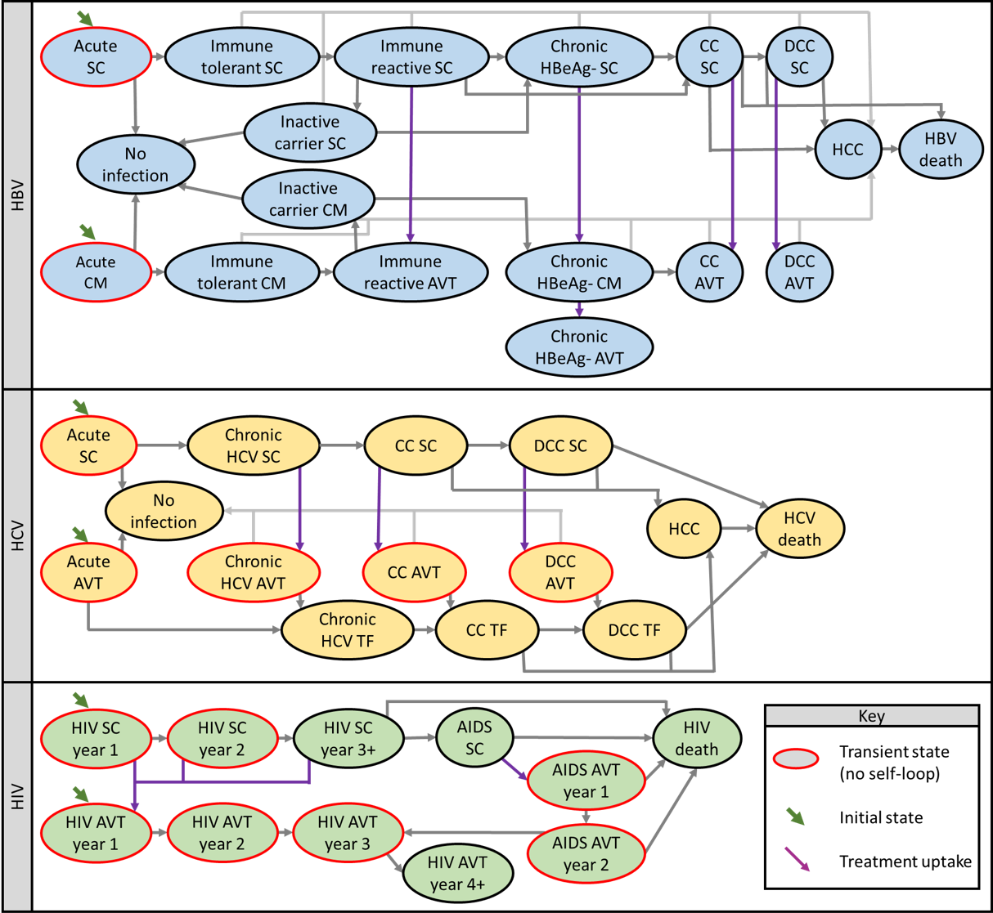

**Fig. 1.** Schematics for Markov models used to estimate net-present lifetime costs for chronic viral infections. Death from other causes possible from any disease state (not shown). Abbreviations AVT, antiviral therapy, CC, compensated cirrhosis, CM, clinical monitored, DCC, decompensated cirrhosis, HCC, hepatocellular carcinoma, HBV, hepatitis B, HCV, hepatitis C, HIV, human immunodeficiency virus, TF, treatment failure, SC, subclinical

##### 

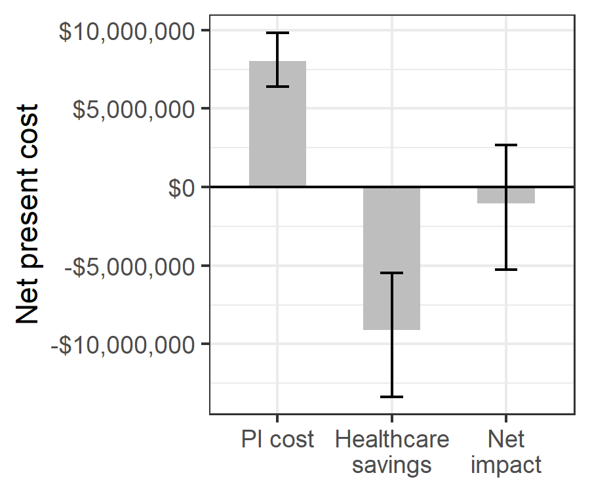

**Fig. 2.** Estimated net impact on healthcare spending of whole blood pathogen inactivation. Net impact is the cost of pathogen inactivation minus the net present healthcare savings from avert transfusion-related adverse events.

##### 

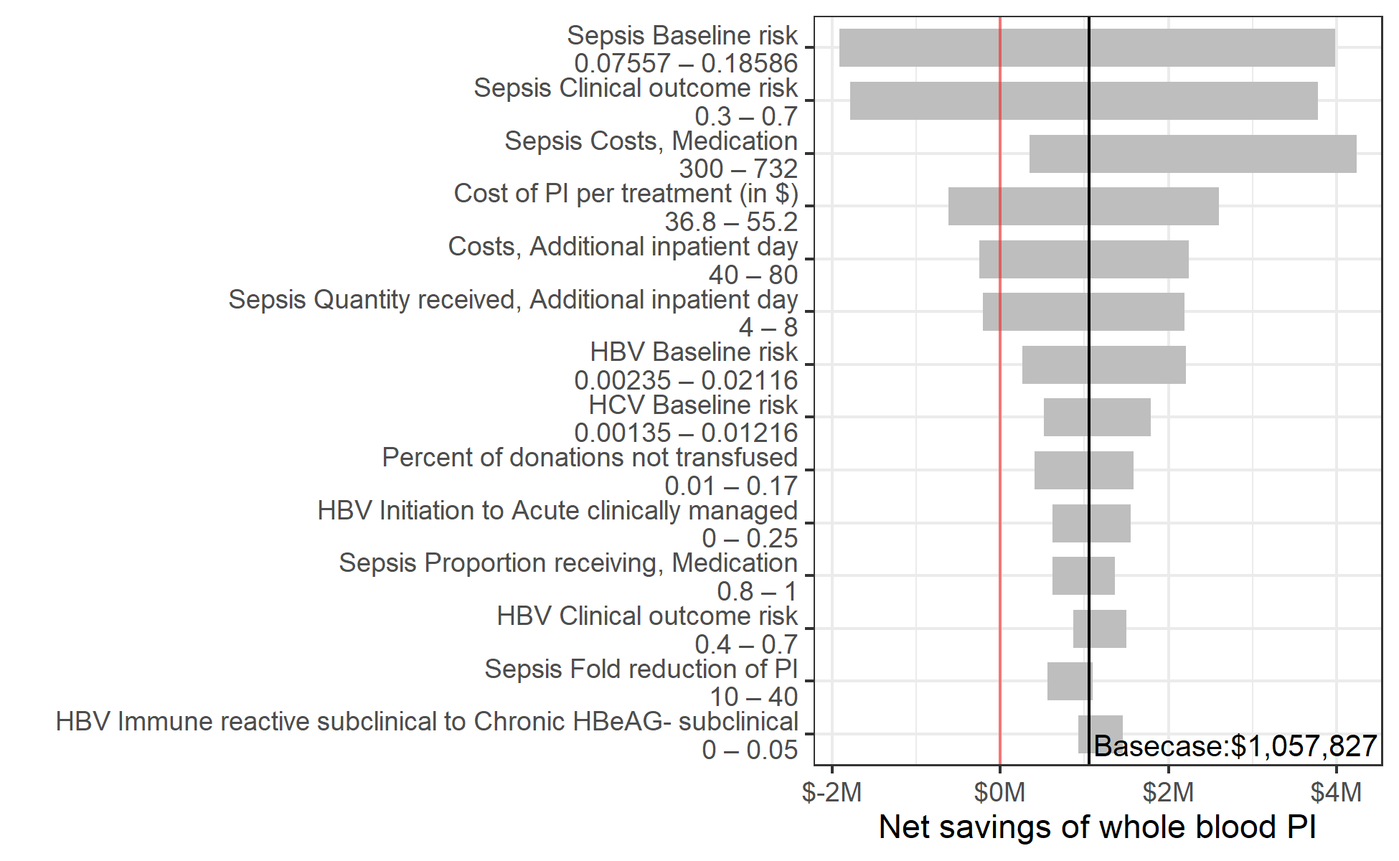

**Fig. 3.** Sensitivity of the net savings of pathogen inactivation to changes in the value of individual input parameters within prespecified uncertainty ranges. Y-axis shows all model parameters for which varying the value along the indicated range while keeping other parameters at their base case value led to a variation of more than $500,000 in the estimated net savings of whole blood pathogen inactivation.

##### 

# Supplemental materials

# A. Risk model calculations

The following equation was used to calculate the number of cases of each adverse event [AE], with and without PI:

$$\begin{matrix}([AE] Cases without PI)= & (\#whole blood donations)× \\ & ([AE] baseline risk)× \\ & ([AE] clinical outcome risk)\end{matrix}$$

$$\begin{matrix}[AE] Cases with PI= & (\#whole blood donations)× \\ & ([AE] baseline risk)× \\ & ([AE] clinical outcome risk)× \\ & ([AE] transmissibility)\end{matrix}$$

The annual cost of PI was calculated as:

$$\begin{matrix}PI cost per case= & (\#whole blood donations transfused)× \\ & (1+\% donations not transfused)× \\ & (PI cost per donation.)\end{matrix}$$

# B. Estimation of malaria clinical outcome risk

The risk of clinical malaria infection from the transfusion of a parasitaemic donation was calculated from data in Allain 2016 [8]. In that study, the prevalence of parasitemia was 23% (50/217) in recipients and 25% (91/367) in donors. Parasitemia by malaria species was also reported:

* In donors: 56 had *P falciparum* only; 4 had *P malariae* only; 1 had *P ovale* only; 26 had both *P falciparum* and *P malariae*; and 4 had all 3 species.
* In recipients: 48 had *P falciparum* only; 1 had *P malariae* only; 0 had *P ovale* only; 2 had both *P falciparum* and *P malariae*; and 0 had all 3 species.

From these numbers, we calculated the following probabilities:

* Probability donation has non-falciparum species given that it has malaria: 38.46%
* Probability donation has non-malariae species given that it has malaria: 62.64%
* Probability donation has non-ovale species given that it has malaria: 94.51%
* Probability donation has neither *P falciparum* nor *P malariae* given that it has malaria: 1.10%

From these, the probability that a parasitaemic recipient who is transfused with a parasitaemic donation would receive a species they are not already parasaetimic for was calculated by taking a sum of the probability donations do not have each set of malaria species weighted by the probability that recipients do have each set of malaria species. The result was 37.47%.

The probability of clinical outcomes when a malaria-positive donation is transfused to a non-parasitaemic recipient was reported as 21.6% (8 of 37 transfusions) with a 95% confidence interval of 9.8–38.2%. We assumed that when a parasitaemic donation is transfused to a parasitaemic recipient, the risk of transmission is the same as with a non-parasitaemic recipient when the donation contained a malaria species for which the recipient was not parasitaemic, and the risk of clinical outcomes was 0 when the recipient was already parasitaemic with all malaria species in the donation. Therefore, the estimated clinical outcome risk for a parasitaemic recipient was $21.60\%×37.47\%=8.09\%$. We then calculated the overall expected probability of transmission of a malaria parasitaemic donation by weighting the probability in parasitaemic recipients (8.09%) and the probability in non-parasitaemic recipients (21.60%) by the proportion of recipients who were parasitaemic (23%) for an overall risk of clinical outcomes of 18.5%. For the uncertainty range, we assumed the value could range from 45% to 176% of the base case value based on the range in the confidence interval around the risk of transmission from Allain 2016.

##### 

**Table S1** Parameters for the micro-costing calculations

| **Micro-costing parameters** | **Value (range); distribution** | **Source** |
| --- | --- | --- |
| Costs | | |
| Additional inpatient day | 60 (40–80); PERT | Estimated |
| Liver function test | 13 (11–15); PERT | Estimated |
| International normalized ratio test | 7.7 (6.3–9); PERT | Estimated |
| Full blood count | 6.4 (5.5–7.3); PERT | Estimated |
| Blood urea nitrogen, creatinine, & electrolytes | 11.5 (10–13); PERT | Estimated |
| Alpha fetoprotein | 11.5 (11–12); PERT | Estimated |
| Brief outpatient visit | 6 (4–8); PERT | Estimated |
| Extensive outpatient visit | 12 (8–16); PERT | Estimated |
| Abdominal ultrasonography | 10 (8–12); PERT | Estimated |
| Endoscopy with band ligation | 272 (245–350); PERT | Estimated |
| Spironolactone | 350 (182–782); PERT | Estimated |
| Furosemide | 60.8 (55–66); PERT | Estimated |
| Transarterial chemoembolization | 1810 (1400–2200); PERT | Estimated |
| Triphasic CT scan | 173 (150–196); PERT | Estimated |
| Sorafenib (9-12 tablets) | 1920 (1640–2190); PERT | Estimated |
| Medication, Sepsis | 372 (300–732); PERT | Estimated |
| Outpatient clinic visit, Malaria | 15 (10–20); PERT | Estimated |
| RDT + Microscopy, Malaria | 3 (1–5); PERT | Estimated |
| Medication, Malaria | 12 (4–20); PERT | Estimated |
| Diagnosis, Syphilis | 15 (10–40); PERT | Estimated |
| Treatment, Syphilis | 12 (5–20); PERT | Estimated |
| Consultation and medication, FNHTR | 25 (20–30); PERT | Estimated |
| HBsAg test, HBV | 3.78 (2.16–5.4); PERT | Estimated |
| HBV profile test, HBV | 35.1 (21.6–48.6); PERT | Estimated |
| HBV DNA test, HBV | 73.8 (72–75.6); PERT | Estimated |
| AVT for non-cirrhotic patients, HBV | 326 (261–391); PERT | Estimated |
| AVT with cirrhosis, HBV | 869 (326–3590); PERT | Estimated |
| Ab screen and confirmation, HCV | 9 (7–13); PERT | Estimated |
| RNA test, HCV | 145 (120–170); PERT | Estimated |
| Genotyping, HCV | 163 (140–186); PERT | Estimated |
| Antiviral medication, HCV | 650 (548–1090); PERT | Estimated |
| AVT for decompensated cirrhosis, HCV | 1630 (1100–2170); PERT | Estimated |
| AIDS care subclinical, HIV | 150 (600–50); PERT | Mikkelsen 2017 |
| HIV care first year on AVT, HIV | 187 (149–224); PERT | Mikkelsen 2017 |
| HIV care second year on AVT, HIV | 64.5 (51.6–77.4); PERT | Mikkelsen 2017 |
| HIV care third year on AVT, HIV | 57 (45.6–68.4); PERT | Mikkelsen 2017 |
| AIDS care first year on AVT, HIV | 585 (436–733); PERT | Estimated1 |
| AIDS care second year on AVT, HIV | 330 (266–393); PERT | Estimated1 |
| HIV care annual cost after third year on AVT, HIV | 46.4 (37.1–55.6); PERT | Mikkelsen 2017 |
| Proportion receiving | | |
| Medication, Sepsis | 90% (80%–100%); PERT | Estimated |
| Additional inpatient day, Malaria | 5% (1%–9%); PERT | Estimated |
| Outpatient clinic visit, Malaria | 50% (40%–60%); PERT | Estimated |
| Diagnosis & treatment, Syphilis | 10% (5%–20%); PERT | Estimated |
| Additional inpatient day, FNHTR | 50% (40%–60%); PERT | Estimated |
| Quantity received | | |
| Additional inpatient day, Sepsis | 6 (4–8); PERT | Estimated |
| Additional inpatient day, Malaria | 1.5 (1–2); PERT | Estimated |
| Outpatient clinic visit, Malaria | 1.2 (1–2); PERT | Estimated |
| Additional inpatient day, FNHTR | 2 (1–3); PERT | Estimated |
| Annual brief outpatient visits for chronic HBeAg-negative infection no AVT, HBV | 3 (2–4); PERT | Estimated |
| Annual brief outpatient visits for chronic HBeAg-negative infection with AVT, HBV | 1 (0–2); PERT | Estimated |
| Annual brief outpatient visits for compensated cirrhosis no AVT, HBV | 3 (2–4); PERT | Estimated |
| Annual brief outpatient visits for compensated cirrhosis with AVT, HBV | 3 (2–4); PERT | Estimated |
| Annual brief outpatient visits for decompensated cirrhosis no AVT, HBV | 4 (2–6); PERT | Estimated |
| Annual brief outpatient visits for decompensated cirrhosis with AVT, HBV | 4 (2–6); PERT | Estimated |
| Annual brief outpatient visits for acute infection with AVT, HCV | 3 (2–4); PERT | Estimated |
| Annual brief outpatient visits for chronic HCV without cirrhosis no AVT, HCV | 3 (2–4); PERT | Estimated |
| Annual brief outpatient visits for compensated cirrhosis no AVT, HCV | 4 (2–6); PERT | Estimated |
| Annual brief outpatient visits with decompensated cirrhosis no AVT, HCV | 4 (2–6); PERT | Estimated |
| 1We assumed patients who initiated AVT after AIDS progression were diagnosed based on symptoms and therefore incurred additional costs for due to AIDS-related illnesses. Costs in the first year were comprised of $57.80 for baseline laboratory investigations, $40.46 in follow-up visits, $255 - $510 for investigation and treatment for AIDS-related illnesses, and $83.04 -- $124.56 for AVT. Costs in the second year were the same, except we assumed only one third as much spending on investigation and treatment for AIDS-related illnesses. | | |

.

##### 

**Table S2** Annual transition probabilities used in the Markov models of chronic HIV, HBV, and HCV infections. Transitions indicated by `#` are calculated as one minus the probability of transitioning to any other state.

| **Annual transition probability** | | **Value (range); distribution** | **Source** |
| --- | --- | --- | --- |
| **From** | **To** |
| HBV natural history | | | |
| Acute subclinical | Immune tolerant subclinical | 95% (90%–99%); PERT | Mafirakureva 2016 |
| No infection | # |  |
| Acute clinically managed | Immune tolerant clinically managed | 95% (90%–99%); PERT | Mafirakureva 2016 |
| No infection | # |  |
| No infection | No infection | 100% |  |
| Immune tolerant subclinical | Immune reactive subclinical | 10% (3%–20%); β(5.063, 45.57) | Nayagam 2016 |
| Hepatocellular carcinoma | 0.3% (0%–0.6%); β(3.985, 1324.35) | Nayagam 2016 |
| Immune tolerant subclinical | # |  |
| Immune tolerant clinically managed | Immune reactive on AVT | 10% (3%–20%); β(5.063, 45.57) | Nayagam 2016 |
| Immune tolerant clinically managed | # |  |
| Carrier subclinical | Chronic HBeAG- subclinical | 2.68% (1.55%–4.71%); β(11.173, 405.74) | Nayagam 2016 |
| Hepatocellular carcinoma | 0.065% (0%–0.1%); β(0.057, 94.89) | Nayagam 2016 |
| No infection | 1% (0.97%–2.26%); β(17.146, 1257.65) | Nayagam 2016 |
| Carrier subclinical | # |  |
| Carrier clinically managed | Chronic HBeAG- clinically managed | 2.68% (1.55%–4.71%); β(11.173, 405.74) | Nayagam 2016 |
| No infection | 1% (0.97%–2.26%); β(17.146, 1257.65) | Nayagam 2016 |
| Carrier clinically managed | # |  |
| Immune reactive subclinical | Chronic HBeAG- subclinical | 0.5% (0%–5%); β(0.154, 30.69) | Nayagam 2016 |
| Carrier subclinical | 5.74% (4.58%–6.88%); β(11.971, 196.76) | Nayagam 2016 |
| Hepatocellular carcinoma | 0.65% (0.27%–1%); β(12.596, 1925.3) | Nayagam 2016 |
| Immune reactive subclinical | # |  |
| Chronic HBeAG- subclinical | Compensated cirrhosis subclinical | 4% (1%–5.2%); β(11.173, 300.92) | Nayagam 2016 |
| Hepatocellular carcinoma | 0.616% (0.27%–1%); β(11.3, 1824.5) | Nayagam 2016 |
| Chronic HBeAG- subclinical | # |  |
| Chronic HBeAG- clinically managed | Compensated cirrhosis on AVT | 4% (1%–5.2%); β(11.173, 300.92) | Nayagam 2016 |
| Hepatocellular carcinoma | 0.616% (0.27%–1%); β(11.3, 1824.5) | Nayagam 2016 |
| Chronic HBeAG- clinically managed | # |  |
| Compensated cirrhosis subclinical | Decompensated cirrhosis subclinical | 3.9% (3.2%–4.6%); β(2.848, 70.18) | Nayagam 2016 |
| Hepatocellular carcinoma | 3.66% (0.8%–8%); β(3.947, 103.88) | Nayagam 2016 |
| HBV-related death | 3.9% (3.9%–50.7%); β(0.27, 6.66) | Nayagam 2016 |
| Compensated cirrhosis subclinical | # |  |
| Decompensated cirrhosis subclinical | Hepatocellular carcinoma | 3.76% (2.3%–7.1%); β(9.411, 240.88) | Nayagam 2016 |
| HBV-related death | 31.4% (4.3%–57%); β(3.583, 7.83) | Nayagam 2016 |
| Decompensated cirrhosis subclinical | # |  |
| Hepatocellular carcinoma | HBV-related death | 50% (40%–100%); β(5.056, 5.06) | Nayagam 2016 |
| Hepatocellular carcinoma | # |  |
| HBV-related death | HBV-related death | 100% | Nayagam 2016 |
| HBV treatment effectiveness | | | |
| Immune reactive on AVT | Immune reactive on AVT | 100% | Nayagam 2016 |
| Chronic HBeAG- on AVT | Chronic HBeAG- on AVT | 100% | Nayagam 2016 |
| Compensated cirrhosis on AVT | Hepatocellular carcinoma | 0.5% (0%–1%); β(0.747, 149) | Nayagam 2016 |
| Compensated cirrhosis on AVT | # |  |
| Decompensated cirrhosis on AVT | Hepatocellular carcinoma | 1% (0%–4.4%); β(0.808, 80) | Nayagam 2016 |
| Decompensated cirrhosis on AVT | # |  |
| HBV treatment uptake | | | |
| Initiation | Acute clinically managed | 10% (0%–25%); PERT | Estimated |
| Acute subclinical | # |  |
| Chronic HBeAG- subclinical | Chronic HBeAG- clinically managed | 5% (10%–20%); PERT | Estimated |
| Chronic HBeAG- clinically managed | Chronic HBeAG- on AVT | 9% (4%–18%); PERT | Estimated |
| Compensated cirrhosis subclinical | Compensated cirrhosis on AVT | 30% (10%–40%); PERT | Estimated |
| Decompensated cirrhosis subclinical | Decompensated cirrhosis on AVT | 70% (50%–90%); PERT | Estimated |
| HCV natural history | | | |
| Acute subclinical | No infection | 31% (15%–40%); PERT | Mafirakureva 2016 |
| Chronic HCV subclinical | # |  |
| No infection | No infection | 100% |  |
| Chronic HCV subclinical | Compensated cirrhosis subclinical | 1.1% (0.5%–1.8%); PERT | Fraser 2016 |
| Chronic HCV subclinical | # |  |
| Chronic HCV treatment failure | Compensated cirrhosis treatment failure | 1.1% (0.5%–1.8%); PERT | Fraser 2016 |
| Chronic HCV treatment failure | # |  |
| Compensated cirrhosis subclinical | Decompensated cirrhosis subclinical | 6.4% (3%–7%); PERT | Fraser 2016 |
| Hepatocellular carcinoma | 3.6% (1.5%–4%); PERT | Fraser 2016 |
| Compensated cirrhosis subclinical | # |  |
| Compensated cirrhosis treatment failure | Decompensated cirrhosis treatment failure | 6.4% (3%–7%); PERT | Fraser 2016 |
| Hepatocellular carcinoma | 3.6% (1.5%–4%); PERT | Fraser 2016 |
| Compensated cirrhosis treatment failure | # |  |
| Decompensated cirrhosis subclinical | Hepatocellular carcinoma | 6.8% (4.1%–9.9%); PERT | Fraser 2016 |
| HCV-related death | 16.8% (12%–40%); PERT | Fraser 2016 |
| Decompensated cirrhosis subclinical | # |  |
| Decompensated cirrhosis treatment failure | Hepatocellular carcinoma | 6.8% (4.1%–9.9%); PERT | Fraser 2016 |
| HCV-related death | 16.8% (12%–40%); PERT | Fraser 2016 |
| Decompensated cirrhosis treatment failure | # |  |
| Hepatocellular carcinoma | HCV-related death | 60.5% (30%–80%); PERT | Fraser 2016 |
| Hepatocellular carcinoma | # |  |
| HCV-related death | HCV-related death | 100% | Fraser 2016 |
| HCV treatment effectiveness | | | |
| Acute on AVT | No infection* | 95% (90%–99%); PERT | Fraser 2016 |
| Chronic HCV treatment failure | # |  |
| Chronic HCV on AVT | No infection | 95% (90%–99%); PERT | Fraser 2016 |
| Chronic HCV treatment failure | # |  |
| Compensated cirrhosis on AVT | No infection | 95% (90%–99%); PERT | Fraser 2016 |
| Compensated cirrhosis treatment failure | # |  |
| Decompensated cirrhosis on AVT | No infection | 95% (90%–99%); PERT | Fraser 2016 |
| Decompensated cirrhosis treatment failure | # |  |
| HCV treatment uptake | | | |
| Initiation | Acute on AVT | 10% (0%–25%); PERT | Estimated |
| Acute subclinical | # |  |
| Chronic HCV subclinical | Chronic HCV on AVT | 10% (5%–30%); PERT | Estimated |
| Compensated cirrhosis subclinical | Compensated cirrhosis on AVT | 30% (10%–40%); PERT | Estimated |
| Decompensated cirrhosis subclinical | Decompensated cirrhosis on AVT | 70% (50%–90%); PERT | Estimated |
| HIV natural history | | | |
| No ART, 1st year | No ART, 2nd year | 100% |  |
| No ART, 2nd year | No ART, 3+ years | 100% |  |
| No ART, 3+ years | AIDS (pediatric) | 4.21% (3.07%–5.62%); PERT | Morgan 2002 |
| AIDS (adult) | 15% (10.1%–22.6%); PERT | Morgan 2002 |
| HIV-related death (pediatric) | 1.5% (0%–6.9%); PERT | Morgan 2002 |
| HIV-related death (adult) | 0% (0%–5.5%); PERT | Morgan 2002 |
| No ART, 3+ years | # |  |
| AIDS subclinical | HIV-related death (pediatric) | 60.2% (32.4%–60.2%); PERT | Morgan 2002 |
| HIV-related death (adult) | 61.5% (28.6%–64.9%); PERT | Morgan 2002 |
| AIDS subclinical | # |  |
| HIV-related death | HIV-related death | 100% | Morgan 2002 |
| HIV treatment uptake | | | |
| Initiation | ART year 1 | 7.5% (0%–15%); PERT | Estimated |
| HIV subclinical year 1 | # |  |
| HIV subclinical year 1 | ART year 1 | 7.1% (0%–13%); PERT | Estimated |
| HIV subclinical year 2 | ART year 1 | 18.6% (7%–31%); PERT | Estimated |
| HIV subclinical year 3+ | ART year 1 | 30% (14%–47%); PERT | Estimated |
| AIDS subclinical | AIDS on ART year 1 | 50% (30%–70%); PERT | Estimated |
| HIV treatment effectiveness | | | |
| ART year 1 | ART year 2 | 100% | Assumed |
| ART year 2 | ART year 3 | 100% | Assumed |
| ART year 3 | ART year 4+ | 100% | Assumed |
| ART year 4+ | ART year 4+ | 100% | Assumed |
| AIDS on ART year 1 | HIV-related death | 30% (15%–40%); PERT | Estimated |
| AIDS on ART year 2 | # |  |
| HIV-related death | 15% (0%–30%); PERT | Estimated |
| AIDS on ART year 2 | ART year 3 | # |  |

##### 

**Table S3** Calculations used for each disease state (acute illness for sepsis, malaria, febrile non-hemolytic transfusion reactions, and syphilis; annual costs for each disease state in the HBV and HIV Markov models)

| **Disease state** | **Microcosting calculation** |
| --- | --- |
| Sepsis | (cost × quantity) additional inpatient days +  (proportion × cost) medication |
| Malaria | (cost × quantity × proportion) additional inpatient days +  (cost × quantity × proportion) outpatient clinic visits +  (cost) diagnosis +  (cost) medication |
| FNHTR | (cost) medication and consult +  (cost × quantity × proportion) additional inpatient days |
| Syphilis | (cost × proportion) diagnosis +  (cost × proportion) medications |
| HBV acute clinically managed | (2 × cost) HBsAg test +  (cost) HBV profile +  (cost) HBV DNA test +  (cost) extensive outpatient clinic visit +  (cost) brief outpatient clinic visit |
| HBV acute subclinical | 0 |
| HBV no infection | 0 |
| HBV immune tolerant clinically managed | (cost) extensive outpatient clinic visit +  (cost) HBsAg test +  (cost) HBV profile +  (cost) HBV DNA test +  (cost) liver function test |
| HBV immune tolerant subclinical | 0 |
| HBV carrier subclinical | 0 |
| HBV carrier clinically managed | 0 |
| HBV immune reactive on AVT | cost) extensive outpatient clinic visit +  (cost) HBsAg test +  (cost) HBV profile +  (cost) HBV DNA test +  (cost) liver function test +  (cost) HBV antivirals for non-cirrhotic patients |
| HBV immune reactive subclinical | 0 |
| HBV chronic HBeAg- on AVT | (cost) liver function test +  (cost) HBV profile +  (cost) HBV DNA test +  (cost) blood urea nitrogen, creatinine, & electrolytes +  (cost) full blood count +  (cost) alpha fetoprotein test +  (cost) abdominal ultrasonography +  (cost × quantity) brief outpatient visit +  (cost) HBV antivirals for non-cirrhotic patients |
| HBV chronic HBeAg- clinically managed | (cost) liver function test +  (cost) HBV profile +  (cost) HBV DNA test +  (cost) blood urea nitrogen, creatinine, & electrolytes +  (cost) full blood count +  (cost) alpha fetoprotein test +  (cost) abdominal ultrasonography +  (cost × quantity) brief outpatient visit |
| HBV chronic HBeAg- subclinical | 0 |
| HBV compensated cirrhosis on AVT | (cost) liver function test +  (cost) international normalized ratio test +  (2 × cost) HBV DNA test +  (cost) blood urea nitrogen, creatinine, & electrolytes +  (cost) full blood count +  (2 × cost) alpha fetoprotein test +  (2 × cost) abdominal ultrasonography +  (cost × quantity) brief outpatient visit |
| HBV compensated cirrhosis subclinical | 0 |
| HBV decompensated cirrhosis on AVT | (cost) liver function test +  (cost) international normalized ratio test +  (2 × cost) HBV DNA test +  (cost) blood urea nitrogen, creatinine, & electrolytes +  (cost) full blood count +  (2 × cost) alpha fetoprotein test +  (2 × cost) abdominal ultrasonography +  (cost × quantity) brief outpatient visit +  (cost) HBV antivirals for patients with cirrhosis |
| HBV decompensated cirrhosis subclinical | 0 |
| HBV hepatocellular carcinoma | (cost) liver function test +  (cost) international normalized ratio test +  (cost) Full blood count +  (cost) alpha fetoprotein test +  (cost) triphasic CT scan +  (cost) endoscopy with band ligation +  (cost) sorafenib +  (cost) transarterial chemoembolization |
| HBV related death or other-cause death | 0 |
| HCV acute subclinical | 0 |
| HCV acute with AVT | (cost) Ab screen and confirmation +  (2 × cost) HCV RNA test +  (cost) HCV genotyping +  (cost) liver function test +  (cost) Blood urea nitrogen, creatinine, & electrolytes +  (cost × quantity) brief outpatient visit +  (cost) HCV antivirals |
| HCV no infection | 0 |
| HCV chronic subclinical | 0 |
| HCV chronic with AVT | (cost) liver function test +  (cost) Blood urea nitrogen, creatinine, & electrolytes +  (cost) Full blood count +  (cost) alpha fetoprotein test +  (cost) abdominal ultrasonography +  (cost) HCV genotyping +  (2 × cost) HCV RNA test +  (cost × quantity) brief outpatient visit  (cost) HCV antivirals |
| HCV chronic treatment failure | (cost) liver function test +  (cost) Blood urea nitrogen, creatinine, & electrolytes +  (cost) Full blood count +  (cost) alpha fetoprotein test +  (cost) abdominal ultrasonography +  (cost) HCV genotyping +  (2 × cost) HCV RNA test +  (cost × quantity) brief outpatient visit |
| HCV compensated cirrhosis subclinical | 0 |
| HCV compensated cirrhosis with AVT | (cost) liver function test +  (cost) international normalized ratio test +  (cost) Blood urea nitrogen, creatinine, & electrolytes +  (cost) Full blood count +  (2 × cost) alpha fetoprotein test +  (2 × cost) abdominal ultrasonography +  (cost) HCV genotyping +  (2 × cost) HCV RNA test +  (cost × quantity) brief outpatient visit  (cost) HCV antivirals |
| HCV compensated cirrhosis treatment failure | (cost) liver function test +  (cost) international normalized ratio test +  (cost) Blood urea nitrogen, creatinine, & electrolytes +  (cost) Full blood count +  (2 × cost) alpha fetoprotein test +  (2 × cost) abdominal ultrasonography +  (cost) HCV genotyping +  (2 × cost) HCV RNA test +  (cost × quantity) brief outpatient visit |
| HCV decompensated cirrhosis subclinical | 0 |
| HCV decompensated cirrhosis with AVT | (cost) liver function test +  (cost) international normalized ratio test +  (cost) Blood urea nitrogen, creatinine, & electrolytes +  (cost) Full blood count +  (2 × cost) alpha fetoprotein test +  (2 × cost) abdominal ultrasonography +  (cost) HCV genotyping +  (3 × cost) HCV RNA test +  (2 × cost) endoscopy with band ligation +  (cost) spironolactone +  (cost) furosemide +  (cost × quantity) brief outpatient visit  (cost) HCV antivirals |
| HCV decompensated cirrhosis treatment failure | (cost) liver function test +  (cost) international normalized ratio test +  (cost) Blood urea nitrogen, creatinine, & electrolytes +  (cost) Full blood count +  (2 × cost) alpha fetoprotein test +  (2 × cost) abdominal ultrasonography +  (cost) HCV genotyping +  (3 × cost) HCV RNA test +  (2 × cost) endoscopy with band ligation +  (cost) spironolactone +  (cost) furosemide +  (cost × quantity) brief outpatient visit |
| HCV hepatocellular carcinoma | (cost) liver function test +  (cost) international normalized ratio test +  (cost) Full blood count +  (cost) alpha fetoprotein test +  (cost) triphasic CT scan +  (cost) endoscopy with band ligation +  (cost) sorafenib +  (cost) transarterial chemoembolization |
| HCV related death or other-cause death | 0 |
| ART initiation with AIDS | ART costs + baseline labs + follow-up labs + LFT |
| ART initiation with AIDS (typical) |  |
| ART initiation with AIDS (high) |  |

##### 

**Table S4** Calculated annual costs for each disease state in the HIV, HBV, and HCV disease progression Markov models

| **Disease state** | **Annual cost** | **Undiscounted Lifetime cost, Adult** | **Undiscounted Lifetime cost, Pediatric** | **Net present lifetime cost, Adult** | **Net present lifetime cost, Pediatric** |
| --- | --- | --- | --- | --- | --- |
| HBV | | | | | |
| Acute clinically managed | $134.46 | $6.72 | $6.72 | $6.72 | $6.72 |
| Acute subclinical | $0.00 | $0.00 | $0.00 | $0.00 | $0.00 |
| Carrier clinically managed | $0.00 | $0.00 | $0.00 | $0.00 | $0.00 |
| Carrier subclinical | $0.00 | $0.00 | $0.00 | $0.00 | $0.00 |
| Chronic HBeAG- clinically managed | $179.30 | $89.31 | $311.25 | $40.83 | $97.49 |
| Chronic HBeAG- on AVT | $493.23 | $189.04 | $1,625.93 | $75.87 | $372.47 |
| Chronic HBeAG- subclinical | $0.00 | $0.00 | $0.00 | $0.00 | $0.00 |
| Compensated cirrhosis on AVT | $1,116.34 | $435.83 | $3,222.18 | $178.72 | $769.95 |
| Compensated cirrhosis subclinical | $0.00 | $0.00 | $0.00 | $0.00 | $0.00 |
| Decompensated cirrhosis on AVT | $2,076.14 | $29.53 | $202.94 | $12.13 | $49.62 |
| Decompensated cirrhosis subclinical | $0.00 | $0.00 | $0.00 | $0.00 | $0.00 |
| HBV-related death | $0.00 | $0.00 | $0.00 | $0.00 | $0.00 |
| Hepatocellular carcinoma | $4,210.60 | $686.46 | $1,172.62 | $431.95 | $579.62 |
| Immune reactive on AVT | $463.61 | $918.23 | $2,239.59 | $514.49 | $861.79 |
| Immune reactive subclinical | $0.00 | $0.00 | $0.00 | $0.00 | $0.00 |
| Immune tolerant clinically managed | $137.68 | $118.06 | $128.63 | $95.30 | $101.08 |
| Immune tolerant subclinical | $0.00 | $0.00 | $0.00 | $0.00 | $0.00 |
| No infection | $0.00 | $0.00 | $0.00 | $0.00 | $0.00 |
| Other-cause death | $0.00 | $0.00 | $0.00 | $0.00 | $0.00 |
| HCV | | | | | |
| Acute on AVT | $1,154.50 | $57.72 | $57.72 | $57.72 | $57.72 |
| Acute subclinical | $0.00 | $0.00 | $0.00 | $0.00 | $0.00 |
| Chronic HCV on AVT | $1,173.40 | $500.69 | $562.66 | $385.60 | $416.95 |
| Chronic HCV subclinical | $0.00 | $0.00 | $0.00 | $0.00 | $0.00 |
| Chronic HCV treatment failure | $523.40 | $307.38 | $694.33 | $174.09 | $279.62 |
| Compensated cirrhosis on AVT | $1,208.60 | $59.74 | $68.95 | $43.42 | $47.98 |
| Compensated cirrhosis subclinical | $0.00 | $0.00 | $0.00 | $0.00 | $0.00 |
| Compensated cirrhosis treatment failure | $558.60 | $32.31 | $70.99 | $17.84 | $28.63 |
| Decompensated cirrhosis on AVT | $3,291.40 | $15.62 | $18.33 | $10.98 | $12.30 |
| Decompensated cirrhosis subclinical | $0.00 | $0.00 | $0.00 | $0.00 | $0.00 |
| Decompensated cirrhosis treatment failure | $1,657.40 | $12.78 | $29.56 | $6.80 | $11.44 |
| HCV-related death | $0.00 | $0.00 | $0.00 | $0.00 | $0.00 |
| Hepatocellular carcinoma | $4,210.60 | $42.65 | $72.52 | $26.82 | $35.89 |
| No infection | $0.00 | $0.00 | $0.00 | $0.00 | $0.00 |
| Other-cause death | $0.00 | $0.00 | $0.00 | $0.00 | $0.00 |
| HIV | | | | | |
| AIDS on ART year 1 | $584.56 | $51.53 | $15.04 | $44.98 | $13.02 |
| AIDS on ART year 2 | $329.56 | $24.63 | $7.24 | $20.88 | $6.08 |
| ART year 1 | $186.70 | $153.99 | $172.12 | $142.21 | $157.71 |
| ART year 2 | $64.52 | $54.47 | $61.02 | $49.00 | $54.46 |
| ART year 3 | $57.02 | $51.99 | $55.10 | $45.20 | $47.68 |
| ART year 4+ | $46.35 | $1,076.14 | $2,484.80 | $618.59 | $1,003.52 |
| HIV-related death | $0.00 | $0.00 | $0.00 | $0.00 | $0.00 |
| Other-cause death | $0.00 | $0.00 | $0.00 | $0.00 | $0.00 |
| Subclinical AIDS | $150.00 | $22.57 | $6.55 | $20.30 | $5.84 |
| Subclinical HIV year 1 | $0.00 | $0.00 | $0.00 | $0.00 | $0.00 |
| Subclinical HIV year 2 | $0.00 | $0.00 | $0.00 | $0.00 | $0.00 |
| Subclinical HIV year 3+ | $0.00 | $0.00 | $0.00 | $0.00 | $0.00 |

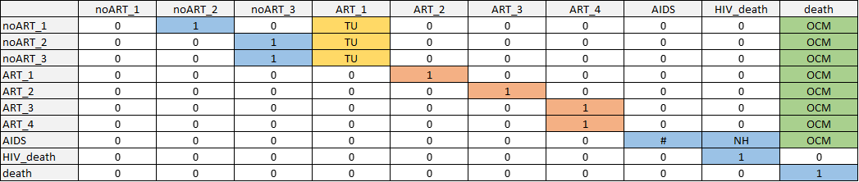

**Fig. S1.** Transition matrix schematic for HIV. Non-zero transition probabilities are indicated in blue for natural history transitions, yellow for treatment uptake transitions, orange for treatment effectiveness transitions, and green for other-cause mortality. Markov model constructed by first creating a transition matrix without treatment uptake or other-cause death; then adding in treatment uptake transitions while scaling other transitions such that each row still sums to 1; then adding in transitions to other-cause mortality with the same approach. Disease state names: AIDS_SC, Subclinical AIDS; ART_1, ART year 1; ART_2, ART year 2; ART_3, ART year 3; ART_4, ART year 4+; HIV_death, HIV-related death; HIV_SC_1, Subclinical HIV year 1; HIV_SC_2, Subclinical HIV year 2; HIV_SC_3, Subclinical HIV year 3+; AIDS_ART_1, AIDS on ART year 1; AIDS_ART_2, AIDS on ART year 2; death, Other-cause death. Abbreviations: NH, natural history (blue); TU, treatment uptake (marigold); TE, treatment effectiveness (orange); OCM, other cause mortality (green)

##### 

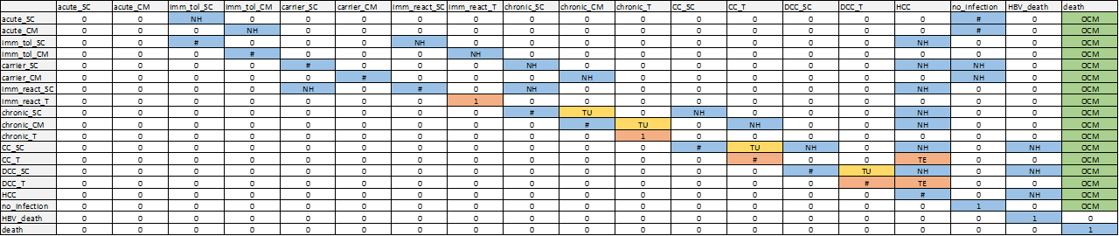

**Fig. S2.** Transition matrix schematic for HBV. Non-zero transition probabilities are indicated in blue for natural history transitions, yellow for treatment uptake transitions, orange for treatment effectiveness transitions, and green for other-cause mortality. Markov model constructed by first creating a transition matrix without treatment uptake or other-cause death; then adding in treatment uptake transitions while scaling other transitions such that each row still sums to 1; then adding in transitions to other-cause mortality with the same approach. Disease state names: acute_CM, Acute clinically managed; acute_SC, Acute subclinical; carrier_CM, Carrier clinically managed; carrier_SC, Carrier subclinical; CC_SC, Compensated cirrhosis subclinical; CC_T, Compensated cirrhosis on AVT; chronic_CM, Chronic HBeAG- clinically managed; chronic_SC, Chronic HBeAG- subclinical; chronic_T, Chronic HBeAG- on AVT; DCC_SC, Decompensated cirrhosis subclinical; DCC_T, Decompensated cirrhosis on AVT; HBV_death, HBV-related death; HCC, Hepatocellular carcinoma; imm_react_SC, Immune reactive subclinical; imm_react_T, Immune reactive on AVT; imm_tol_CM, Immune tolerant clinically managed; imm_tol_SC, Immune tolerant subclinical; init, Initiation; no_infection, No infection; death, Other-cause death. Abbreviations: NH, natural history (blue); TU, treatment uptake (marigold); TE, treatment effectiveness (orange); OCM, other cause mortality (green)

##### 

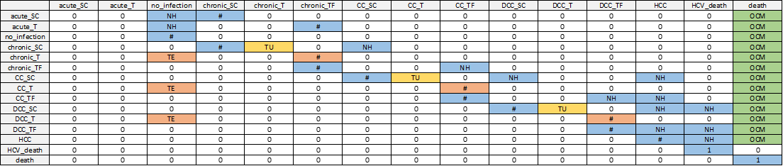

**Fig. S3.** Transition matrix schematic for HCV. Non-zero transition probabilities are indicated in blue for natural history transitions, yellow for treatment uptake transitions, orange for treatment effectiveness transitions, and green for other-cause mortality. Markov model constructed by first creating a transition matrix without treatment uptake or other-cause death; then adding in treatment uptake transitions while scaling other transitions such that each row still sums to 1; then adding in transitions to other-cause mortality with the same approach. Disease state names: acute_SC, Acute subclinical; acute_T, Acute on AVT; CC_SC, Compensated cirrhosis subclinical; CC_T, Compensated cirrhosis on AVT; CC_TF, Compensated cirrhosis treatment failure; chronic_SC, Chronic HCV subclinical; chronic_T, Chronic HCV on AVT; chronic_TF, Chronic HCV treatment failure; DCC_SC, Decompensated cirrhosis subclinical; DCC_T, Decompensated cirrhosis on AVT; DCC_TF, Decompensated cirrhosis treatment failure; HCC, Hepatocellular carcinoma; HCV_death, HCV-related death; init, Initiation; no_infection, No infection; death, Other-cause death. Abbreviations: NH, natural history (blue); TU, treatment uptake (marigold); TE, treatment effectiveness (orange); OCM, other cause mortality (green)

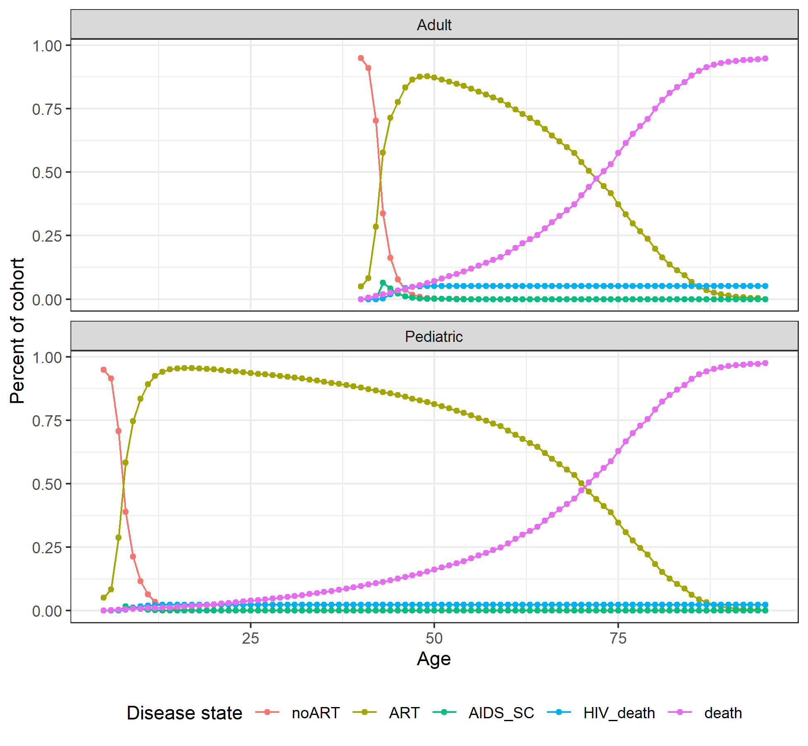

**Fig. S4.** Markov trace plot for HIV pediatric and adult cohorts. Disease state names: AIDS_SC, Subclinical AIDS; ART_1, ART year 1; ART_2, ART year 2; ART_3, ART year 3; ART_4, ART year 4+; HIV_death, HIV-related death; HIV_SC_1, Subclinical HIV year 1; HIV_SC_2, Subclinical HIV year 2; HIV_SC_3, Subclinical HIV year 3+; AIDS_ART_1, AIDS on ART year 1; AIDS_ART_2, AIDS on ART year 2; death, Other-cause death.

##### 

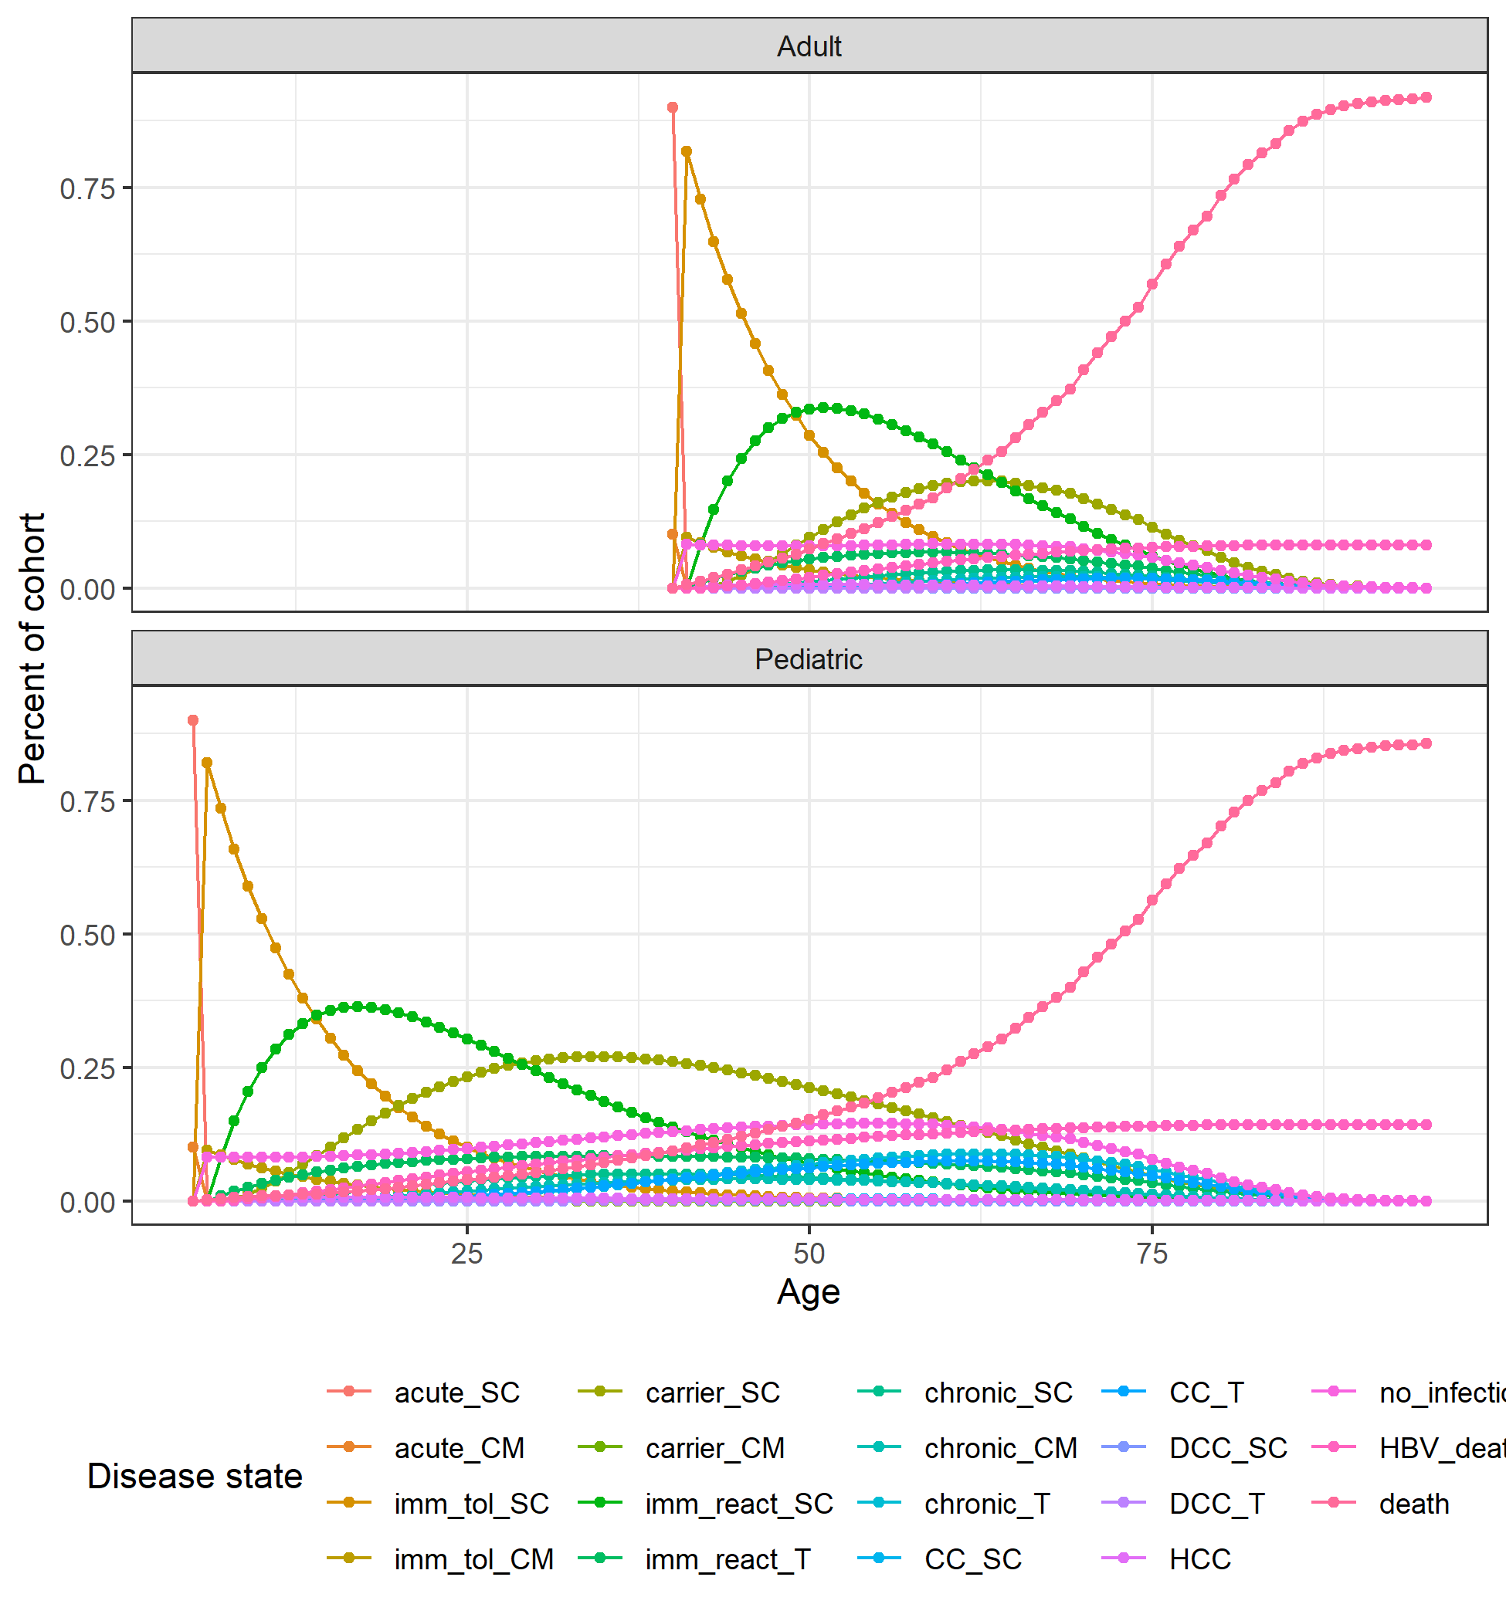

**Fig. S5.** Markov trace plot for HBV pediatric and adult cohorts. Disease state names: acute_CM, Acute clinically managed; acute_SC, Acute subclinical; carrier_CM, Carrier clinically managed; carrier_SC, Carrier subclinical; CC_SC, Compensated cirrhosis subclinical; CC_T, Compensated cirrhosis on AVT; chronic_CM, Chronic HBeAG- clinically managed; chronic_SC, Chronic HBeAG- subclinical; chronic_T, Chronic HBeAG- on AVT; DCC_SC, Decompensated cirrhosis subclinical; DCC_T, Decompensated cirrhosis on AVT; HBV_death, HBV-related death; HCC, Hepatocellular carcinoma; imm_react_SC, Immune reactive subclinical; imm_react_T, Immune reactive on AVT; imm_tol_CM, Immune tolerant clinically managed; imm_tol_SC, Immune tolerant subclinical; init, Initiation; no_infection, No infection; death, Other-cause death.

##### 

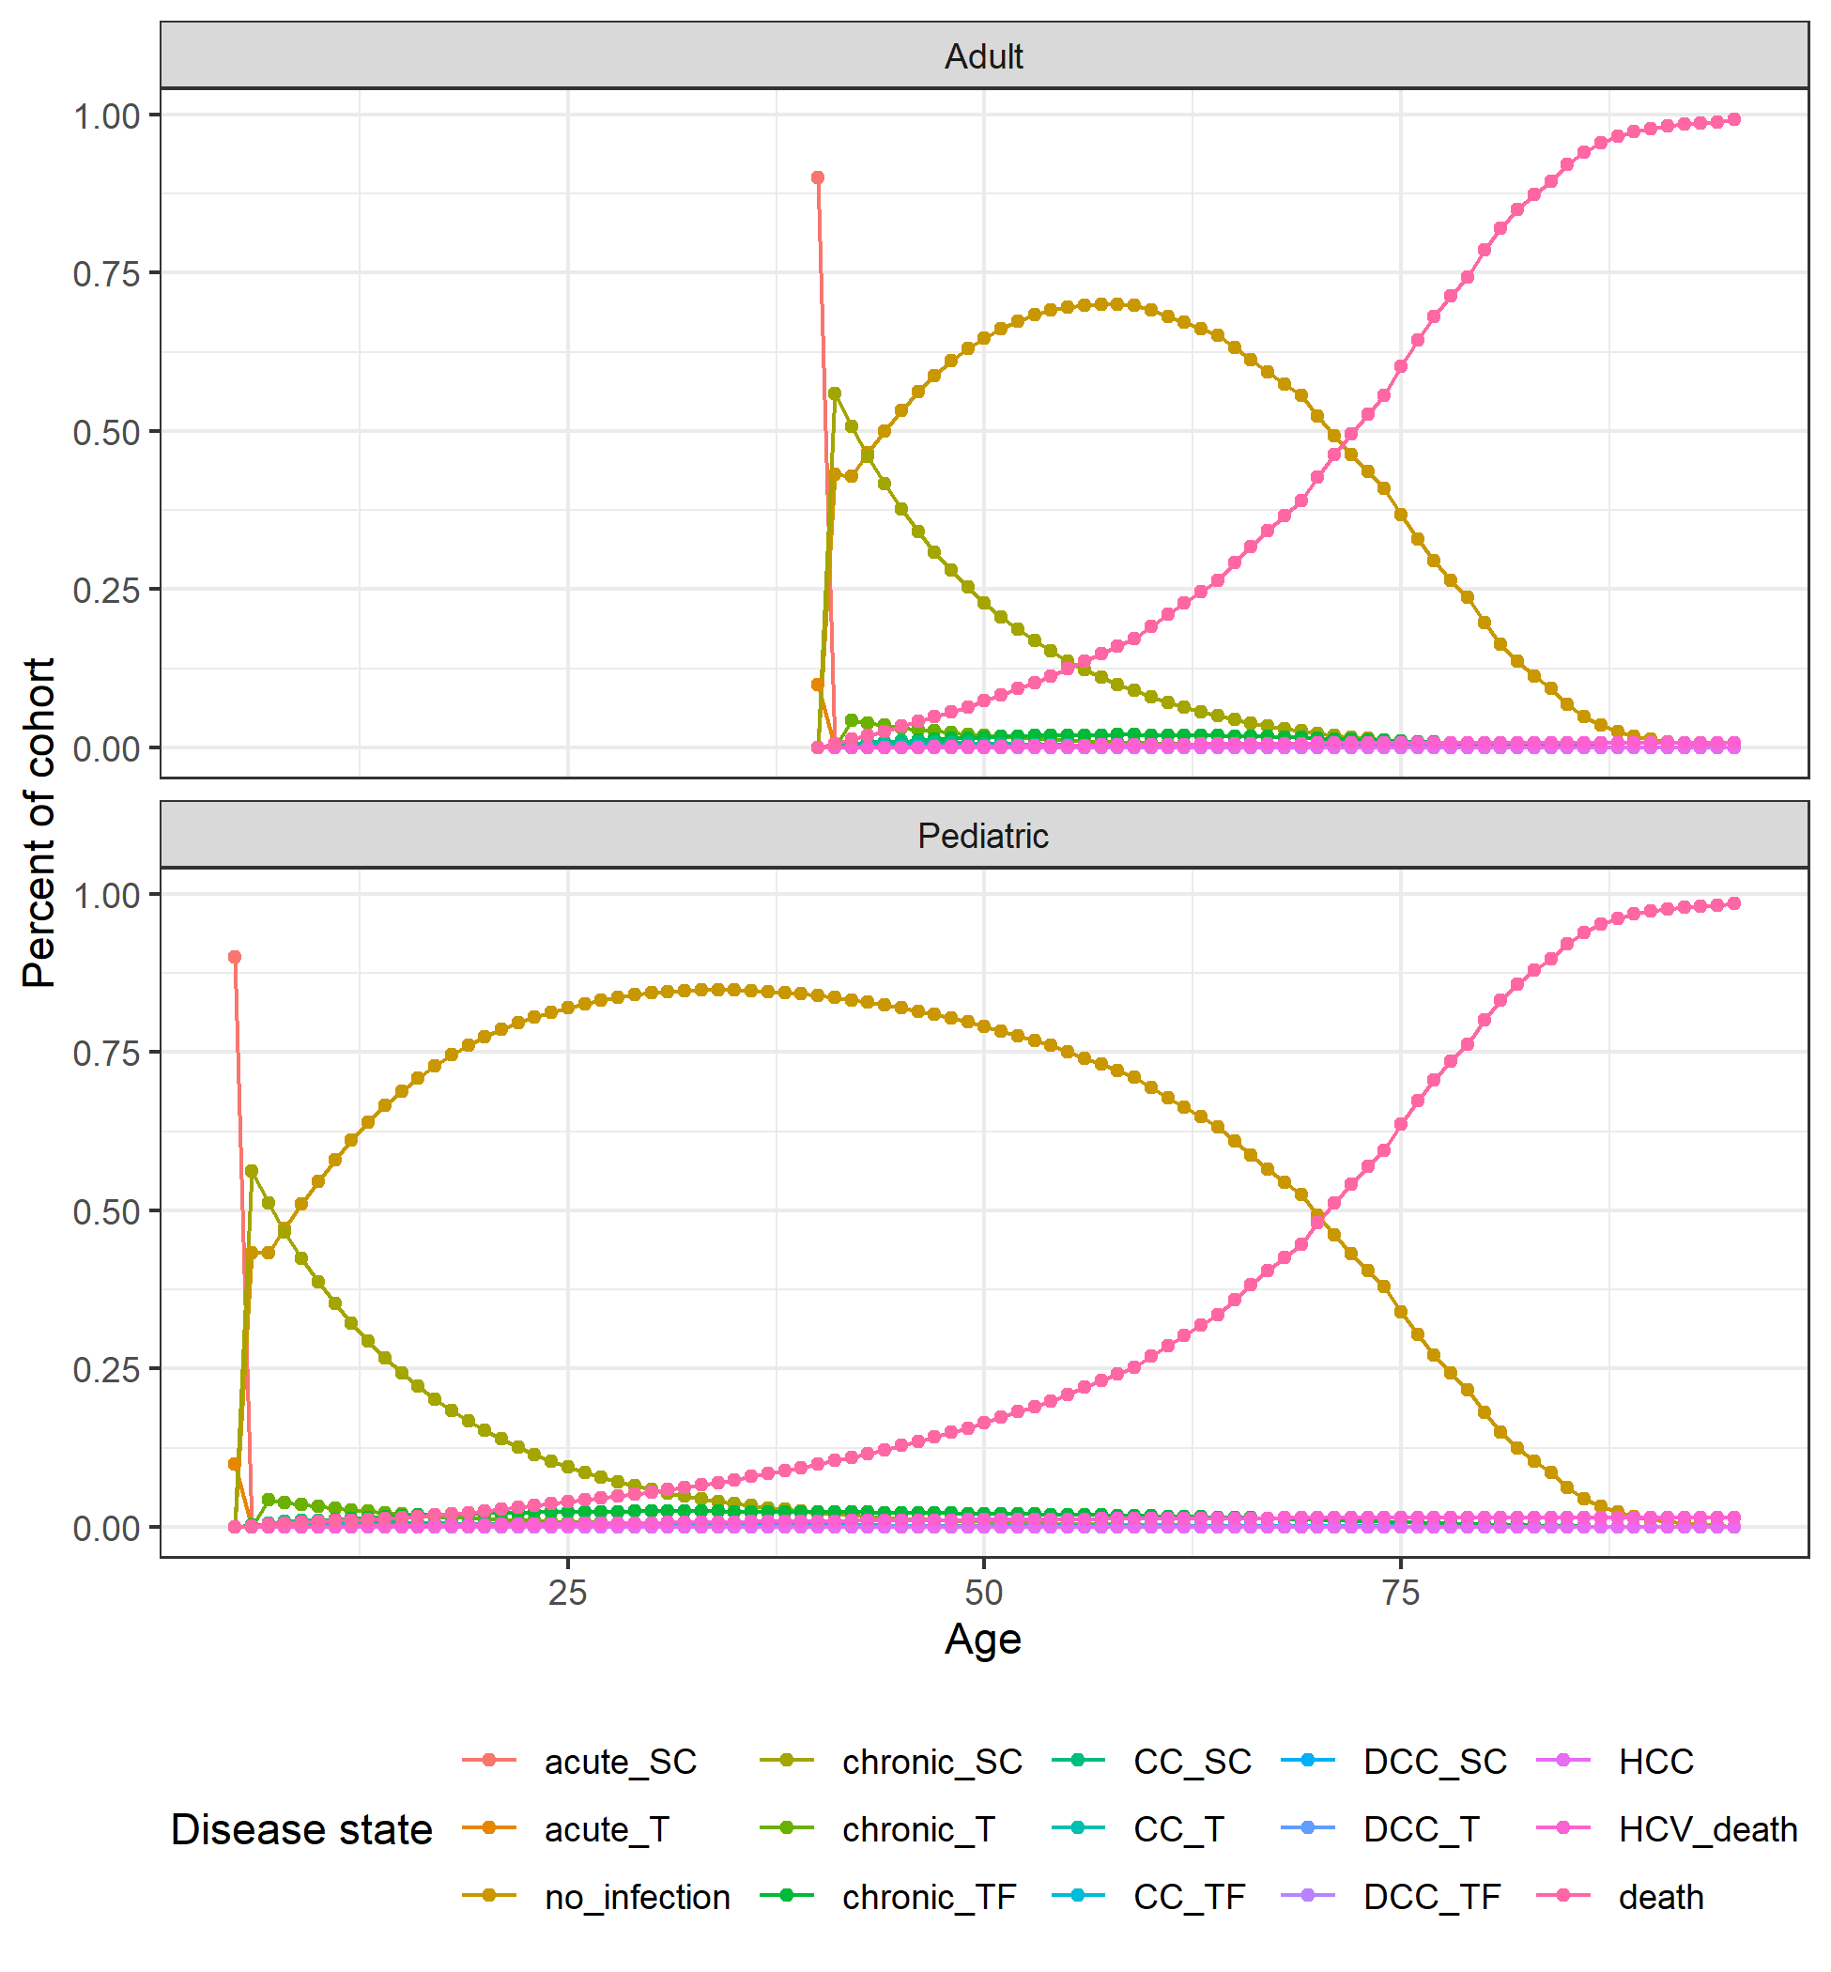

**Fig. S6.** Markov trace plot for HCV pediatric and adult cohorts. Disease state names: acute_SC, Acute subclinical; acute_T, Acute on AVT; CC_SC, Compensated cirrhosis subclinical; CC_T, Compensated cirrhosis on AVT; CC_TF, Compensated cirrhosis treatment failure; chronic_SC, Chronic HCV subclinical; chronic_T, Chronic HCV on AVT; chronic_TF, Chronic HCV treatment failure; DCC_SC, Decompensated cirrhosis subclinical; DCC_T, Decompensated cirrhosis on AVT; DCC_TF, Decompensated cirrhosis treatment failure; HCC, Hepatocellular carcinoma; HCV_death, HCV-related death; init, Initiation; no_infection, No infection; death, Other-cause death.

##### 

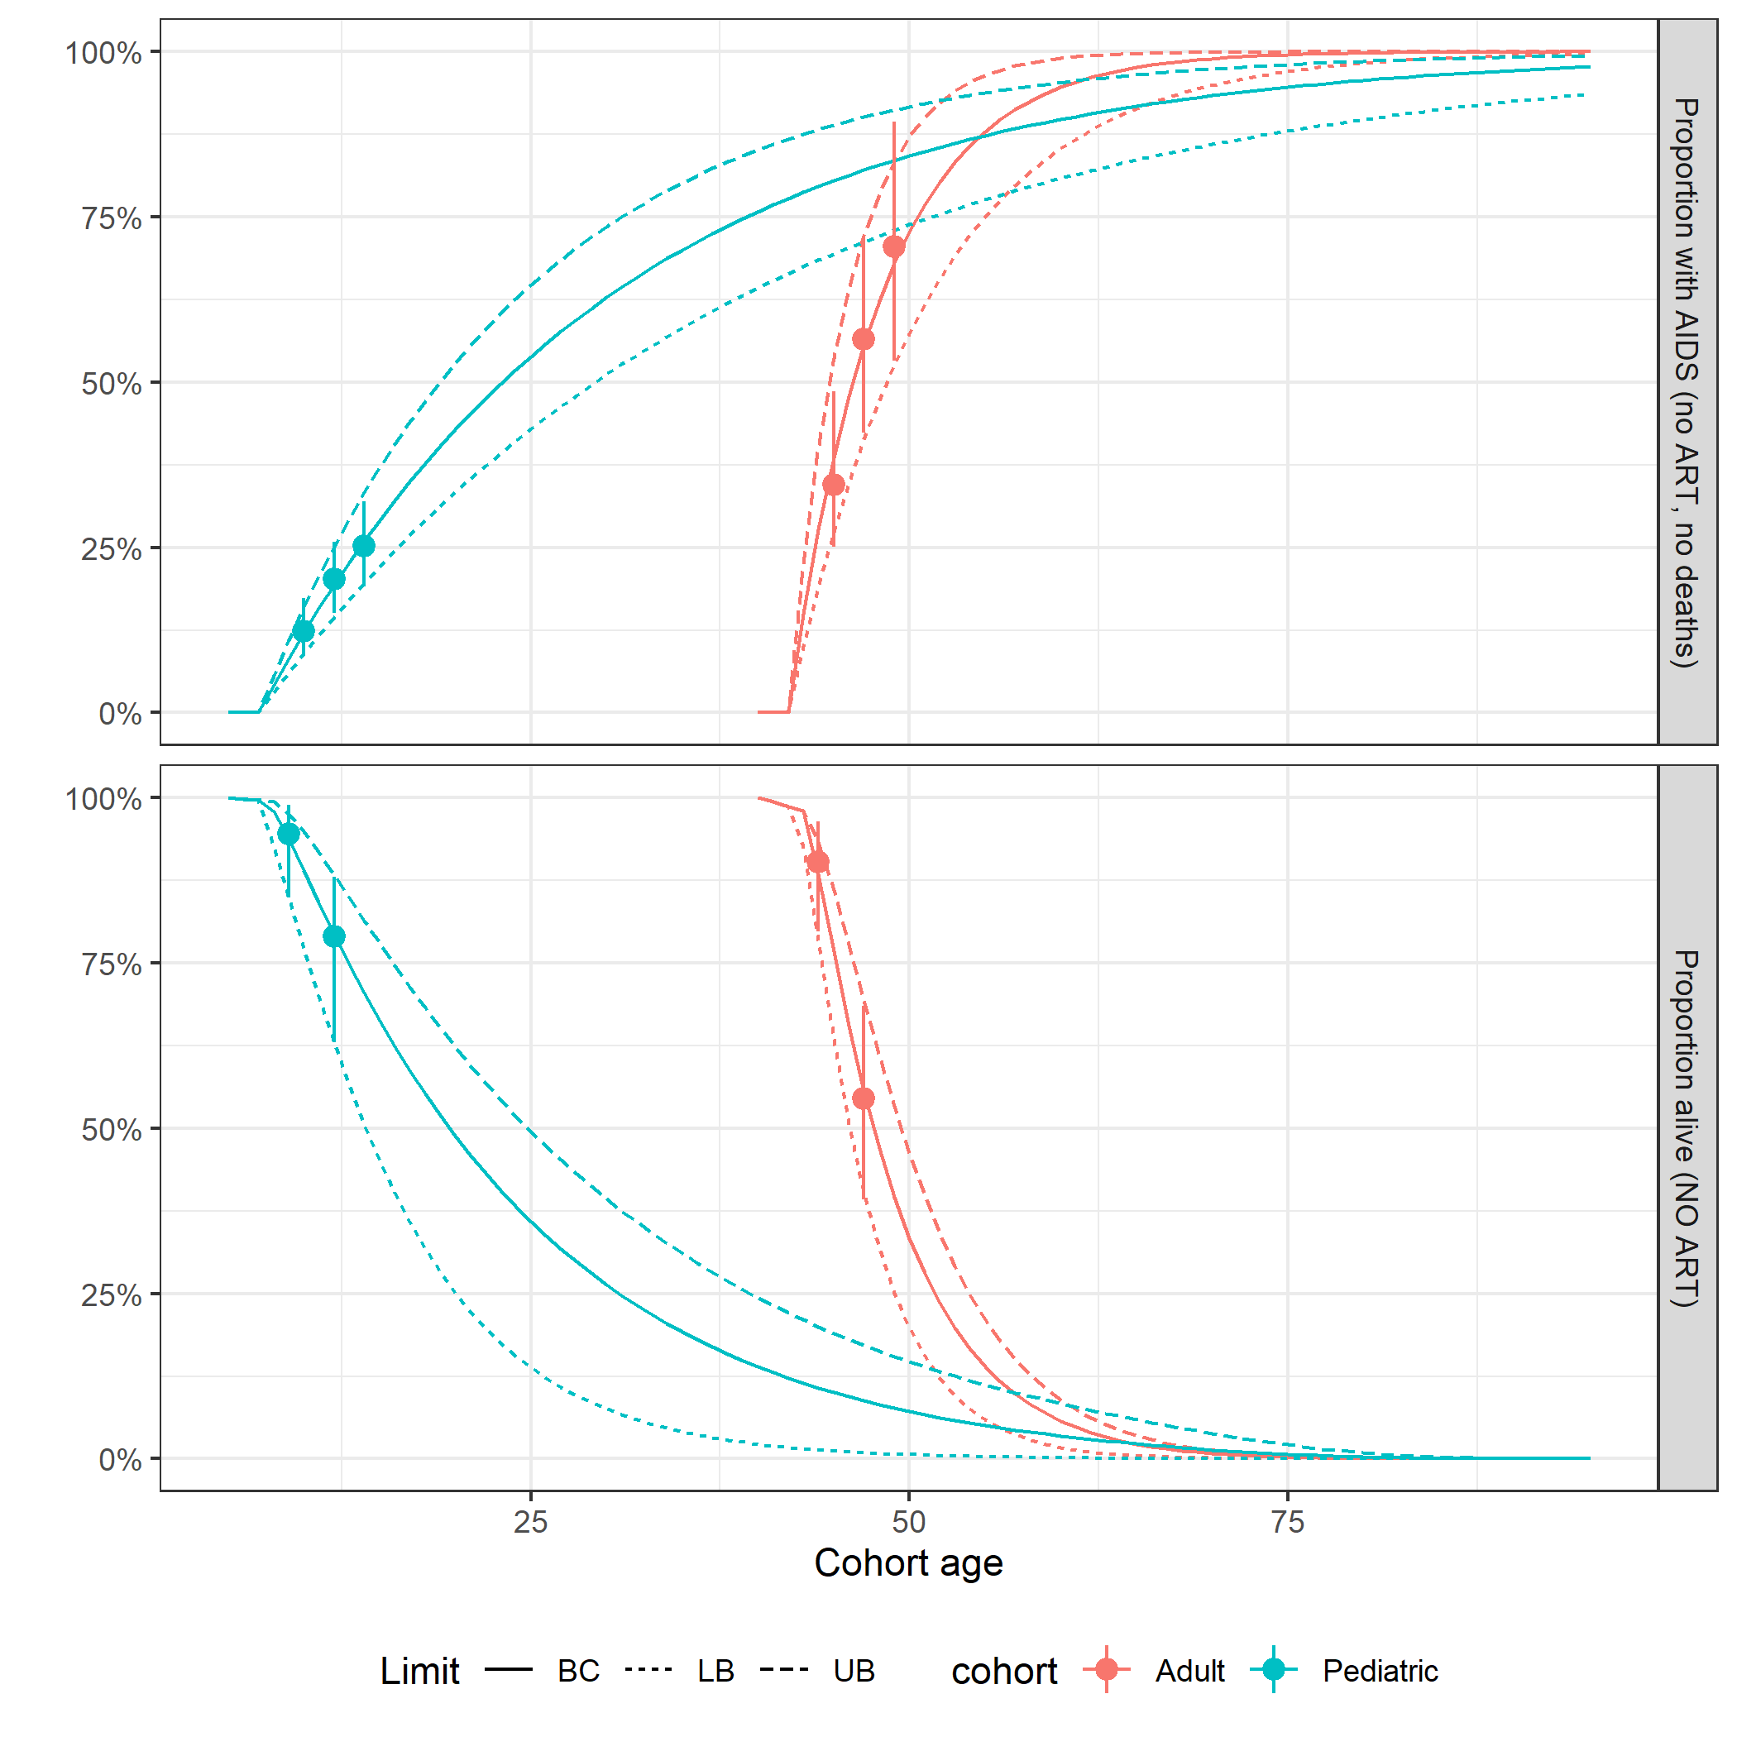

**Fig. S7.** Calibration plots for HIV natural history transition probabilities.